L1
Topic:

Subfield
Def.: 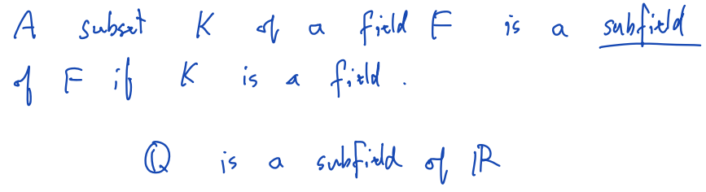

Complex field
Def.: 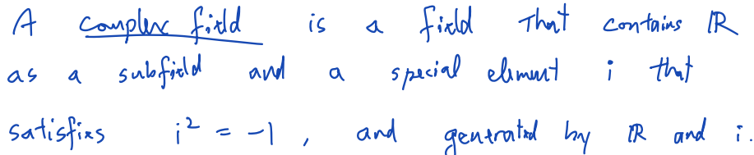

Model 1 – Complex number as a point
Unit: (1, 0)
Zero: (0, 0)
Imaginary unit: (0, 1)

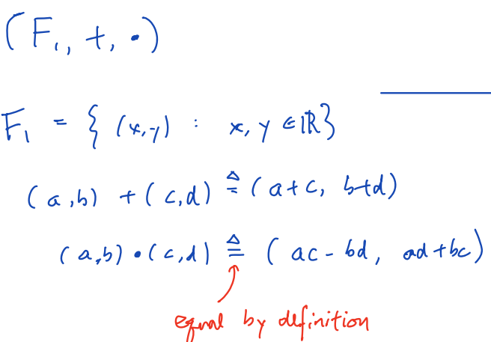

Model 2 – Complex number as a matrix
Unit: 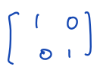
Zero: 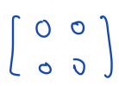
Imaginary unit: 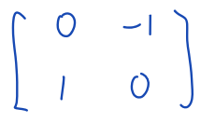

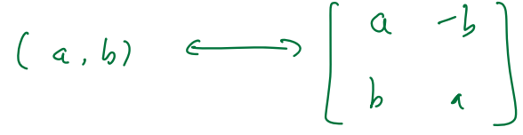
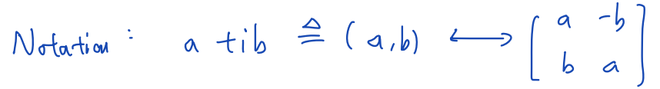
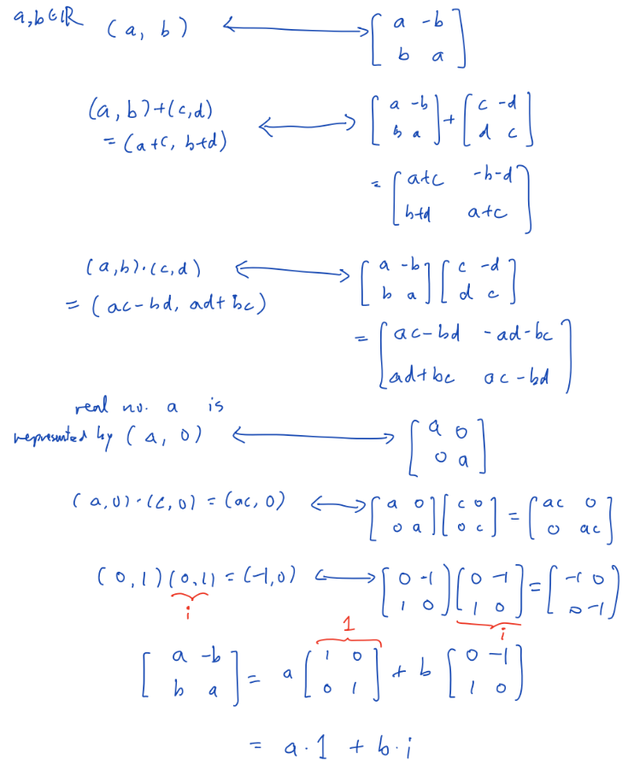

L2
Topic: Multiplication, division, power / roo

$z=x+i·y, then Re\left(z\right)=x, Im\left(z\right)=y$

The modulus / absolute value / radius: $\sqrt{x^{2}+y^{2}}$

Argument / phase / angle: defined up to an integer multiple of 2π

Conjugate: $z^{*}=x-iy$
Properties: 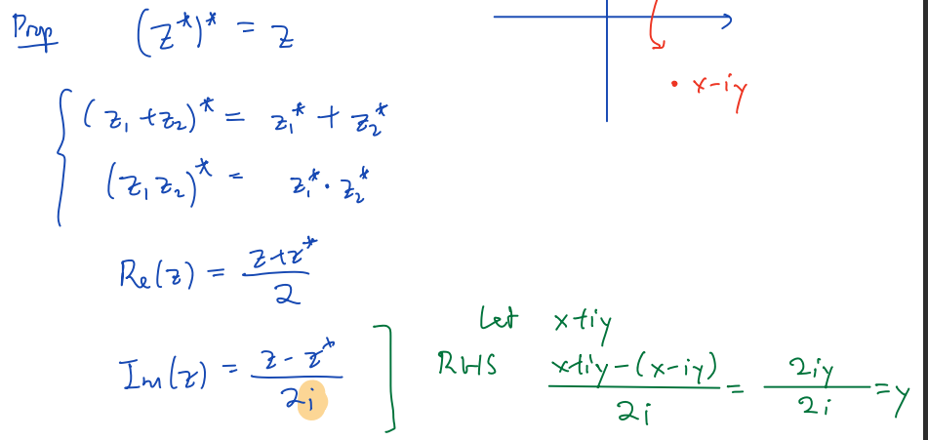
Remarks: Im(z)∈ℝ ; z · z* = |z|^2 = x^2 + y^2

Properties:
1. $\left|z_{1}{·z}_{2}\right|=\left|z_{1}\right|·\left|z_{2}\right|$
2. $\left\{\begin{aligned}z_{1}=r_{1}cosθ_{1}+i·r_{1}sinθ_{1} \\ z_{2}=r_{2}cosθ_{2}+i·r_{2}sinθ_{2}\end{aligned}\right.$ ⇒ $z_{1}·z_{2}=r_{1}·r_{2}·\left(\cos\left(θ_{1}+θ_{2}\right)+i·\sin\left(θ_{1}+θ_{2}\right)\right)$
($z^{n} = r^{n}·(cos\left(nθ\right)+i·sin\left(nθ\right)$)
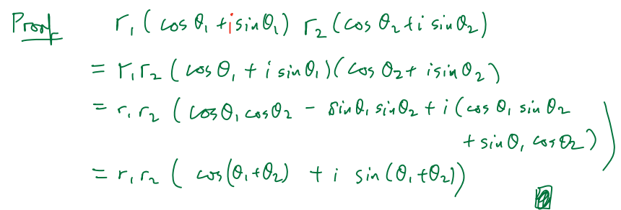

De Moivre Formula
$∀n∈Z, {\left(cosθ+i·sinθ\right)}^{n}=\cos\left(nθ\right)+i·\sin\left(nθ\right)$
Proof: ……

The nth root of a complex number
Given $z^{n}=z_{0}$, find $z$

E.g. 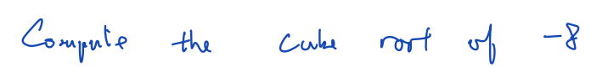
Suppose that z=r(cosθ+i·sinθ) is a solution
Then ${\left(r\left(cosθ+i·sinθ\right)\right)}^{3}=-8$
⇔ $r^{3}\left(cos3θ+i·sin3θ\right)=8\left(\cos\left(π+2kπ\right)+i·sin\left(π+2kπ\right)\right), (k∈Z)$
⇒ $r^{3}=-8$, $3θ=π+2kπ$
⇒ $r=-2$, $θ=\frac{π}{3}+\frac{2}{3}kπ$

L3
Topic: Complex division, principal argument, point at infinity, Riemann sphere

Order in complex number does not exist （复数无法比较大小）
（Proof: 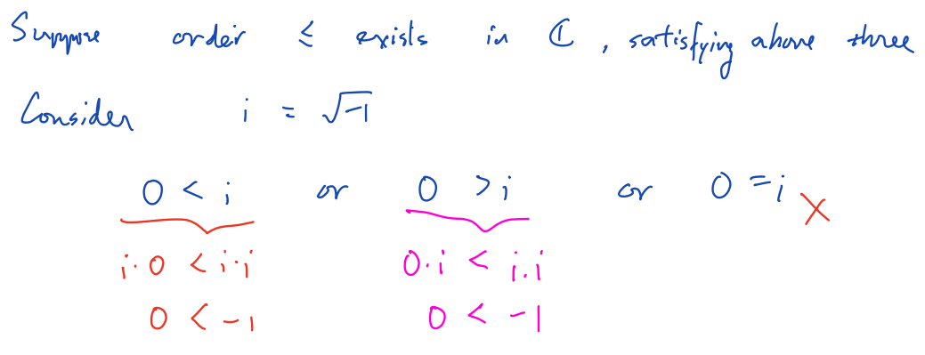）

Colinear
(E.g. (?) )
Given 3 pt.’s (a,b), (c,d), (e,f)
they are colinear
① ⇔ $\frac{d-b}{c-a}=\frac{f-d}{e-c}$
② ⇔ 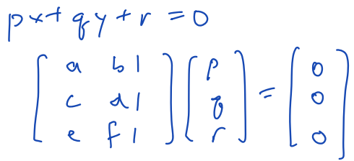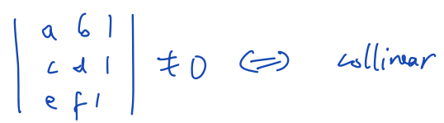

Principal argument
Fix the argument in the interval either [0,2π) or (-π, π]
Notation: Arg(z)

E.g.: 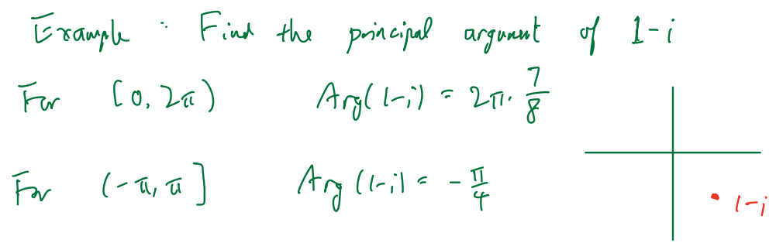

$Arg\left(\frac{z_{1}}{z_{2}}\right)=\left(Arg\left(z_{1}\right)-Arg\left(z_{2}\right)\right) \left(?\right) mod 2π$
$∃k∈Z, s.t. Arg\left(\frac{z_{1}}{z_{2}}\right)-\left(Arg\left(z_{1}\right)-Arg\left(z_{2}\right)\right)=2πk$
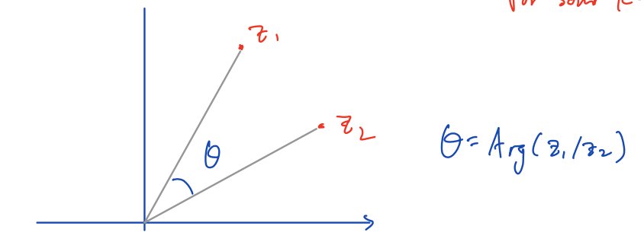

Given 3 pt.’s in complex plane: z_1, z_2, z_3
They’re colinear
⇔ $arg\left(\frac{z_{1}-z_{2}}{z_{3}-z_{2}}\right)=0 or π ( \left[0,2π\right) or \left(-π,π\right] )$
⇔ $imag\left(\frac{z_{1}-z_{2}}{z_{3}-z_{2}}\right)=0$

Inverse function (?)
……

Linear fractional transformation (LFT)
(translation) $f\left(z\right)=z+b, b∈C$
(rotation) $f\left(z\right)=z\left(cosθ+i·sinθ\right)$
(dilation) $f\left(z\right)=r·z, r∈R$
(inversion) $f\left(z\right)=\frac{1}{z}$

translation: $f\left(z\right)=\frac{a·z+b}{c·z+d}$, $a, b, c, d∈C, (a·d-b·c)≠0$
(LFT: linear fractional transformations)
Every (?)LFT can be expressed in terms of (?) ……
If c=0: 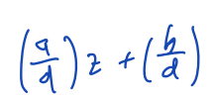
If c≠0: 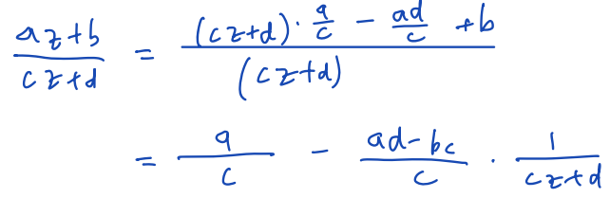

Riemann sphere
For $f\left(z\right)=\frac{1}{z}$
WT: define ……(?) ∞
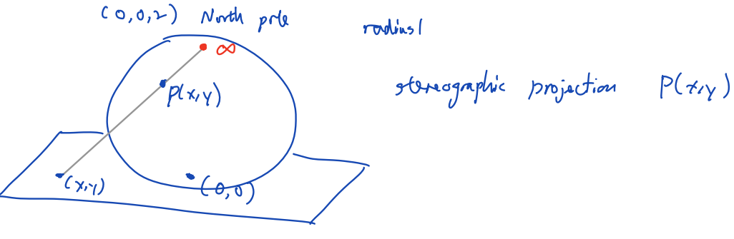

L4
Topic : Linear functional transformation (又：Möbius transformation), properties LFT

Extended complex plane
Def.: $C∪\{∞\}$
Notation: 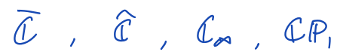

（（？） affine function ）
……

L5
Topic: Complex sequence,series, complex exp function, Euler’s formula

(definition) $exp\left(z\right)=e^{z}=\sum_{k=0}^{∞}{\frac{z^{k}}{k!}}$
(theorem (Brown & Churchill)) $e^{z}=e^{x}\left(cosy+i·siny\right) (z=x+i·y)$

Complex plane as a (?)metric(?) space
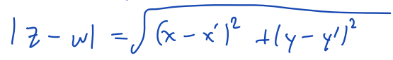
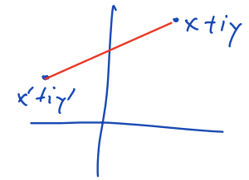
Triangle inequality
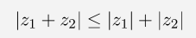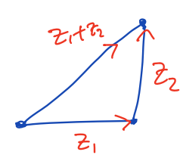

Open disc centered at z_0 wiith radius r
Def.: 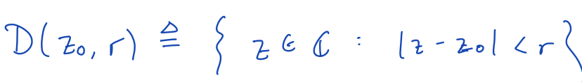
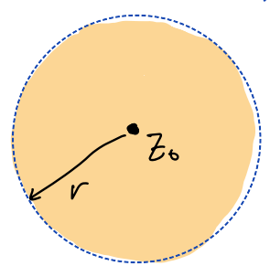

Open set S
Def.: a set S is open
⇔ $∀z_{0}∈S, ∃r>0,$
$s.t. D\left(z_{0},r\right)⊆S$

Digression
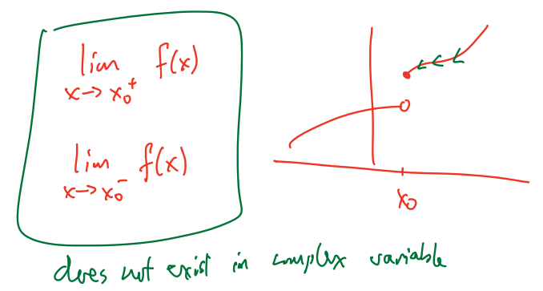

Open disc centered at ∞
Def.: 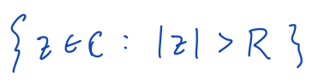, ∀positive number R
(?) 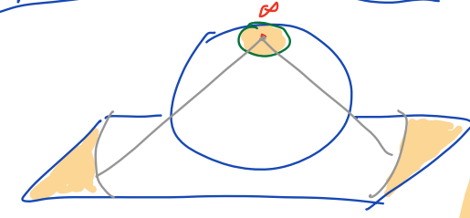

Sequence
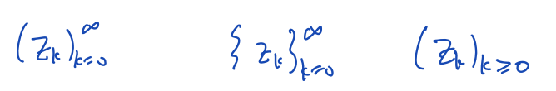
A sequence ${\left(z_{k}\right)}_{k=0}^{∞}$ converges to L∈ℂ
⇔ $∀ε>0, ∃N∈N$
s.t. $∀k≥N, \left|z_{k}-L\right|<ε$
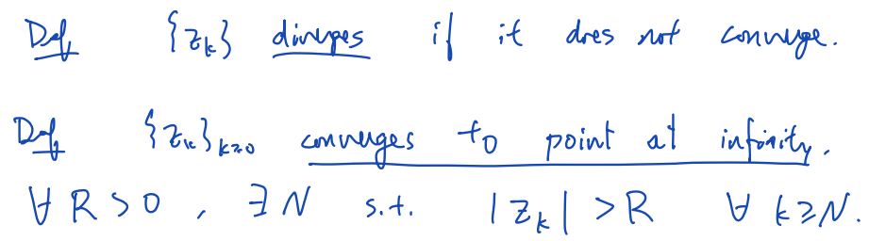
Properties:
${\left(z_{k}\right)}_{k=0}^{}$ converges to L∈ℂ
⇔ $\left\{\begin{aligned}{\left(Re(z_{k})\right)}_{k≥0}^{∞} converges to Re\left(L\right) \\ {\left(Im(z_{k})\right)}_{k≥0}^{∞} converges to Im\left(L\right)\end{aligned}\right.$

A sequence ${\left(z_{k}\right)}_{k=0}^{∞}$ is Cauchy
⇔
Properties:
① a sequence is Cauchy ⇔ the sequence is convergent
② 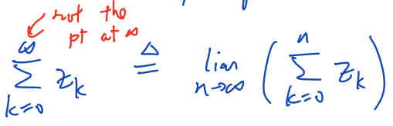
③ ${\left(z_{k}\right)}_{k=0}^{}$ converges ⇐ 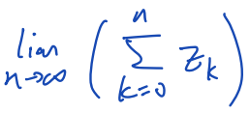 exists

E.g.:

(nth term test) 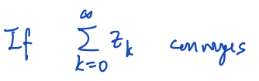 ⇒ 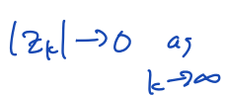
(absolute convergent test) 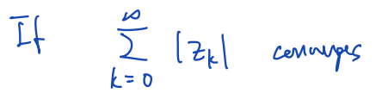 ⇒ 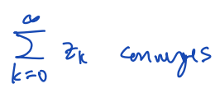
(limit ratio test) 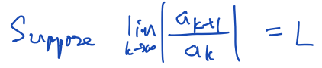
If L>1 ⇒ then 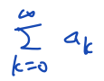 diverges
If L<1 ⇒ then converges absolutely
If L=1: no conclusion

E.g.: (?) 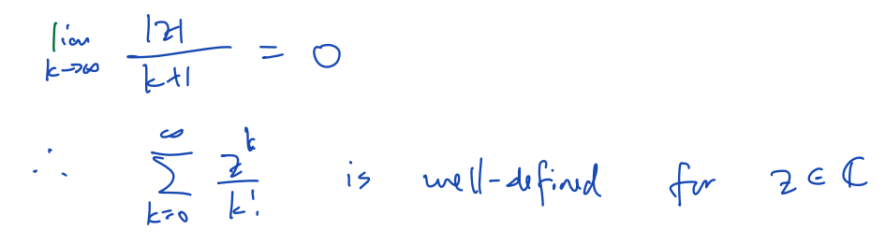(?)

A series is absolute convergence
⇒ any re-arrangement of the order of summation gives (???)some limit

$e^{z}$=exp(z) (notation)
Properties:
……

L6
Topic: Complex trigonometric function, complex log, complex power

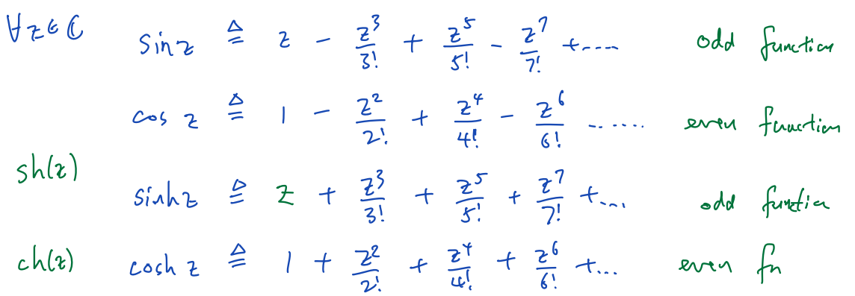

Euler: $e^{iθ}=cosθ+i·sinθ$
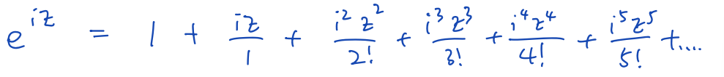
!! ($e^{z}=e^{x}·e^{iy}=e^{x}·(\cos\left(y\right)+i·\sin\left(y\right))$)
!! ($i=\cos\left(\frac{π}{2}\right)+i·\sin\left(\frac{π}{2}\right)=e^{i\frac{π}{2}}$)

Theorem: $∀z∈C,{\cos^{2}{z}+sin}^{2}{z=1}$
Proof:
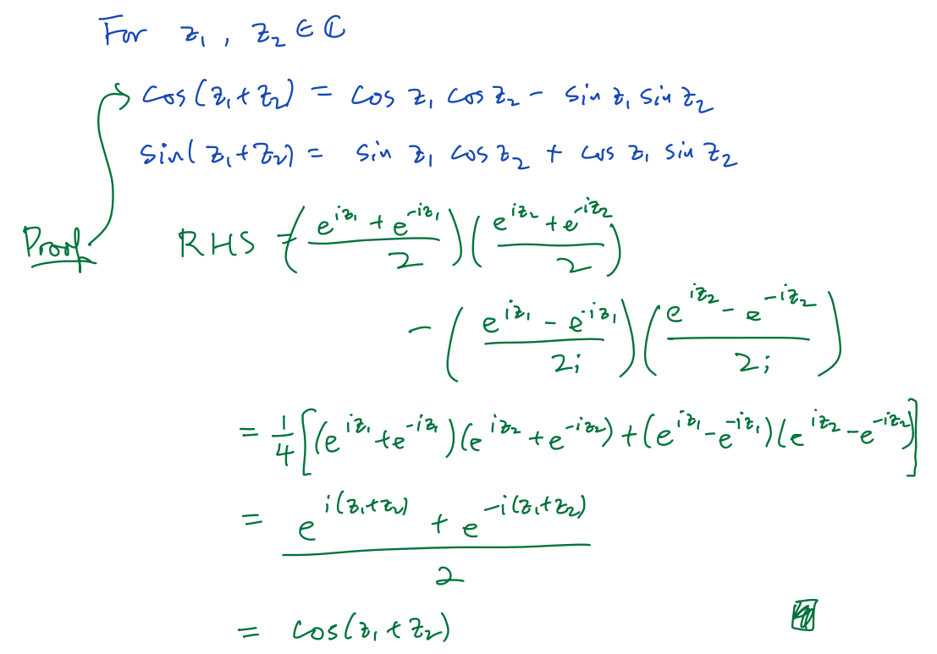

Complex log function
$e^{z}=w ⇔z=\log\left(w\right) (∀w∈C)$
Def.: $\log\left(w\right)=\ln\left|w\right|+i·\left(\arg\left(w\right)+2πk\right) (k∈Z)$

E.g.: Calculate $\log\left(4i\right)$
Write $z=x+iy$, want $e^{z}=4i$
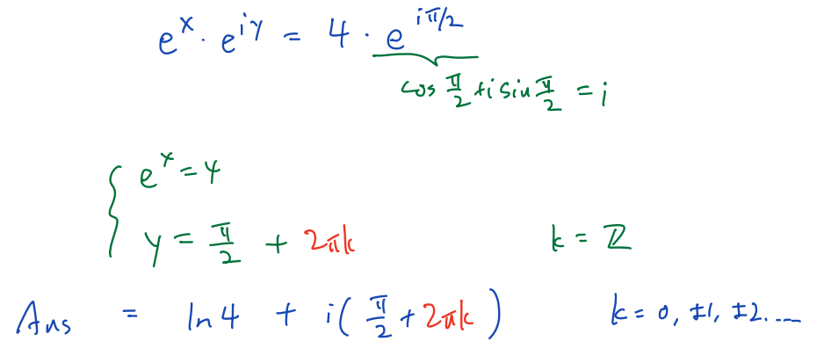 (!! 注意由sin/cos/tan 解 角度(θ，此处是y) 要加上 +2πk或+πk !! (k∈ℤ))

Principal log function
Def.: $Log\left(w\right)=ln\left|w\right|+i·Arg\left(w\right)$

Complex power
Def.: $z^{w}≜e^{w·\log\left(z\right)}$

E.g.: ……

Principal value: $e^{i·\log\left(i\right)}=e^{- \frac{π}{2}}$

Inverse trigonometric function
E.g.: Find a complex number z, s.t. cos(z) = 3
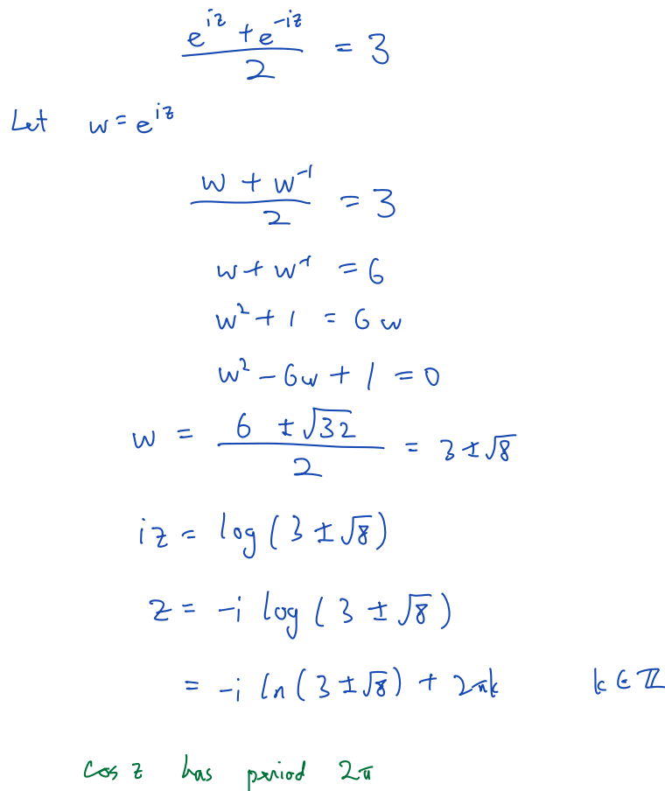

L7
Topic: Complex differentiable function, Cauchy-Riemann equation

Complex function
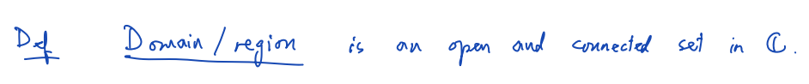
is continuous at point (z_0)
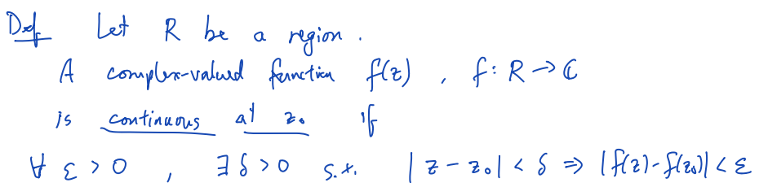
is continuous
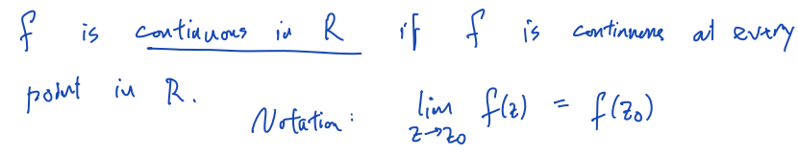
(图示，关于cont. at point)
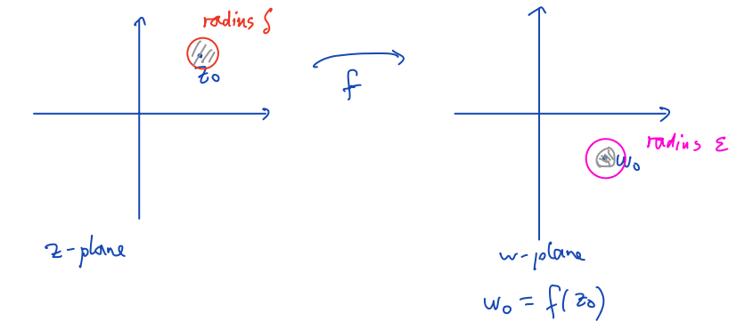
(Example here)

Theorem: (ccf. 的 cont. 充要条件 ←→ 关于 实&虚 部)
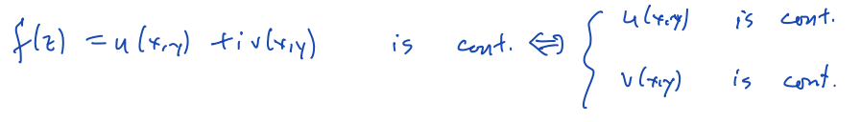
（Complex function）
Is complex differentiable at point ($z_{0}=x_{0}+i·y_{0}$)
⇔ $\lim_{Δz→0}{\frac{f\left(z_{0}+Δz\right)-f\left(z_{0}\right)}{Δz}} exists$
⇒ (必要条件) (Cauchy-Riemann equations)
$\left\{\begin{aligned}u_{x}(x_{0},y_{0})=v_{y}(x_{0},y_{0}) \\ u_{y}(x_{0},y_{0})=-v_{x}(x_{0},y_{0})\end{aligned}\right.$ (u(x,y)为f的实部，v(x,y)为f的虚部)

证明：
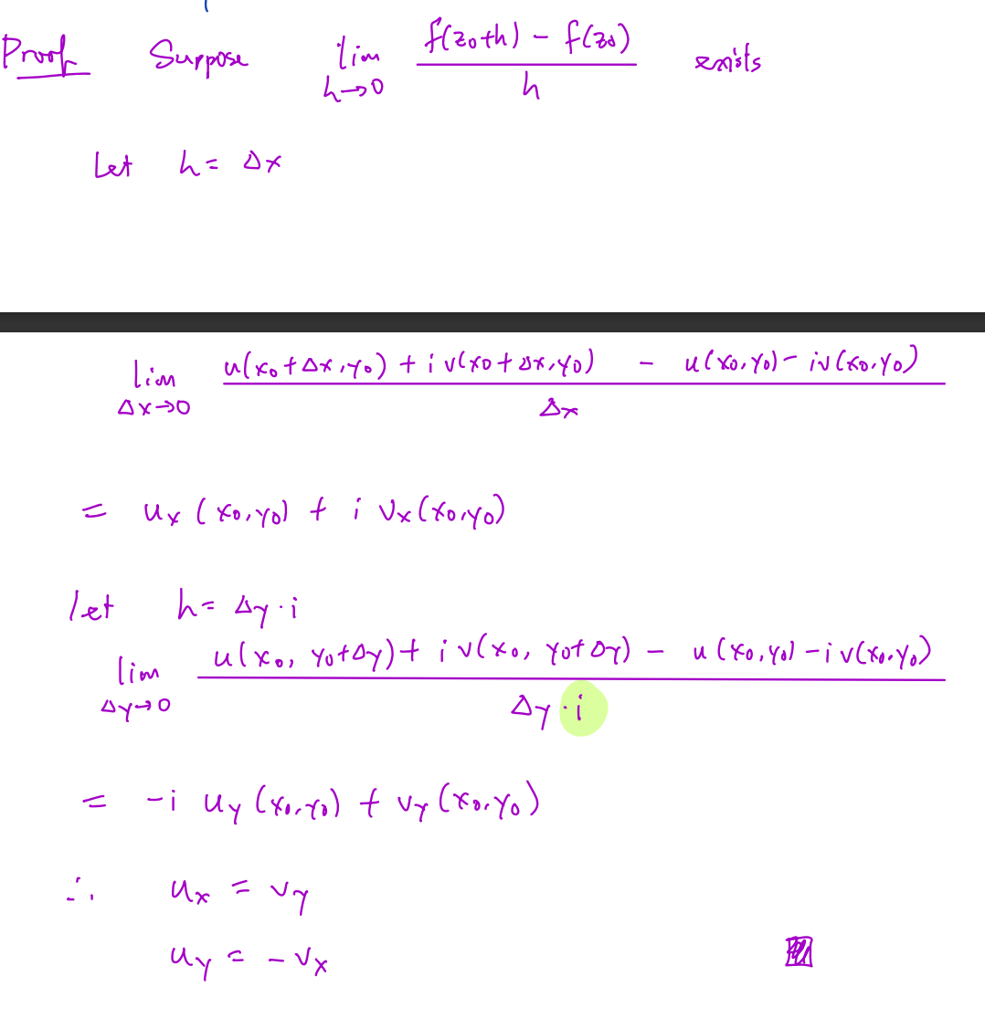

L8
Topic: Holomorphic functions, examples, properties, phase portrait/domain coloning, conformal property

Complex function f(z)
Is holomorphic at point (z_0)
⇔ ∃a neighborhood N,
s.t. ∀z∈N, f(z) is complex differentiable at z
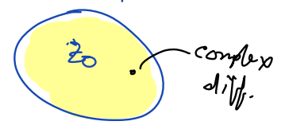
Is holomorphic in a domain D
⇔ ∀z_0∈D, f(z) is holomorphic at z_0

Theorem:
$f\left(z\right)=u\left(x,y\right)+i·v\left(x,y\right)$ is complex differentiable at the point $z_{0}=x_{0}+y_{0}$
⇐ $\left\{\begin{aligned}\left(u\left(x,y\right), v\left(x,y\right)\right) is real differentiable at the point (x_{0},y_{0}) \\ CR equations hold at z_{0}\left(\left\{\begin{aligned}u_{x}\left(x_{0},y_{0}\right)=v_{y}\left(x_{0},y_{0}\right) \\ u_{y}\left(x_{0},y_{0}\right)=-v_{x}\left(x_{0},y_{0}\right)\end{aligned}\right.\right)\end{aligned}\right.$
（……）（?）
Theorem:
$f\left(z\right)=u\left(x,y\right)+i·v\left(x,y\right)$ is complex differentiable at the point $z_{0}=x_{0}+y_{0}$
⇐ $\left\{\begin{aligned}u_{x},u_{y},v_{x},v_{y} are well-defined at the point \left(x_{0},y_{0}\right) \\ u_{x},u_{y},v_{x},v_{y} are continuous in a neighborhood of the point \left(x_{0},y_{0}\right) \\ CR equations hold at z_{0}\left(\left\{\begin{aligned}u_{x}\left(x_{0},y_{0}\right)=v_{y}\left(x_{0},y_{0}\right) \\ u_{y}\left(x_{0},y_{0}\right)=-v_{x}\left(x_{0},y_{0}\right)\end{aligned}\right.\right)\end{aligned}\right.$

E.g. …… (??)

Complex function f(z)
Is entire
⇔ ∀z∈ℂ, f is complex differentiable at z

E.g. ……

Differentiation rules
(f, g are complex differentiable functions)
${\left(f\left(z\right)+g\left(z\right)\right)}^{'}=f^{'}\left(z\right)+g^{'}\left(z\right)$
${\left(f\left(z\right)·g\left(z\right)\right)}^{'}=f^{'}\left(z\right)·g\left(z\right)+f\left(z\right)·g^{'}\left(z\right)$
${\left(\frac{f\left(z\right)}{g\left(z\right)}\right)}^{'}=\frac{f^{'}\left(z\right)·g\left(z\right)-f\left(z\right)·g^{'}\left(z\right)}{g{\left(z\right)}^{2}}$
${\left(a·f\left(z\right)\right)}^{'}=a·f^{'}\left(z\right)$
${\left(f\left(g\left(z\right)\right)\right)}^{'}=f^{'}\left(g\left(z\right)\right)·g^{'}\left(z\right)$
${\left(z^{n}\right)}^{'}=n·z^{n-1}$ (Proof: using mathematical induction)

L9
Topic: Conformed property, harmonic functions, connection to PDE

Remark: Derivative at the point at infinite ∞
( ?)

Conformal property / angle-preserving property
$\left\{\begin{aligned}f is differentiable at z_{0} (z_{0}∈C) \\ f^{'}\left(z_{0}\right)≠0\end{aligned}\right.$
⇒ f is conformal (or: angle-reserving) at $z_{0}$
⇒ $\arg\left(\frac{\frac{d}{dt}f\left(γ_{2}^{'}\left(t_{2}\right)\right)}{\frac{d}{dt}f\left(γ_{1}^{'}\left(t_{1}\right)\right)}\right)=\arg\left(\frac{f^{'}\left(γ_{2}\left(t_{2}\right)\right)}{f^{'}\left(γ_{1}\left(t_{1}\right)\right)}\right)=\arg\left(\frac{γ_{2}^{'}\left(t_{2}\right)}{γ_{1}^{'}\left(t_{1}\right)}\right)=θ$
Explain:
通过$z_{0}$画两条参数曲线$γ_{1}\left(t\right)$和$γ_{2}\left(t\right)$
$γ_{1}\left(t\right)$和$γ_{2}\left(t\right)$在$z_{0}$处的切线之间的角度是$arg⁡(\frac{γ_{2}^{'}\left(t_{2}\right)}{γ_{1}^{'}\left(t_{1}\right)})$，设为θ
$γ_{1}^{'}\left(t\right), γ_{2}^{'}\left(t\right)≠0 ⇒ θ is well-defined$
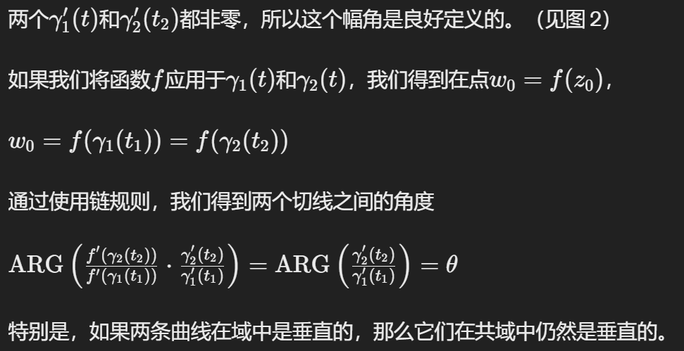 (此处幅角argument；此处co-domain
(???)

（Angle-Preserving (?):共形映射保留两条相交曲线之间的角度。如果两条曲线在一个点相交并形成一定角度，则在对两条曲线应用共形函数后，它们仍将相交并在函数下该点的图像处形成相同的角度。这并不意味着变换后的曲线看起来完全相同;它们可能会被拉伸或压扁，但它们之间的角度保持不变。
Scale Factor (?): 虽然等角贴图保留了角度，但它们可能会局部缩放或扭曲形状。但是，它们在某个点上是一致的，这意味着该点的比例因子在所有方向上都是相同的。）
（共形性质解释了为什么共轭函数 $f\left(z\right)=\overline{z}$ 不是处处可微的。共轭函数在几何上是一个反射，而反射逆转了角度的方向。）

Conformally equivalent
2 regions R_1 & R_2 are conformally equivalent
⇔ ∃a bijective holomorphic map f(z): R_1→R_2

Phase portrait / domain coloring
通过将复函数在平面上的幅角与颜色光谱相联系，来绘制复函数的幅角。这里的颜色对应于幅角的范围 [0, 2π]。亮度对应于复函数的大小。暗点意味着函数值为零。明亮的颜色指示函数大小较大的区域。我们以恒等函数的相位图像作为参考
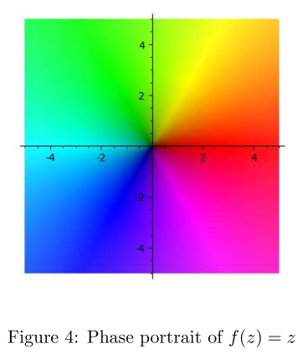

Harmonic function
Def.: …… is twice diff. & partial derivatives are cont.

Laplace equation
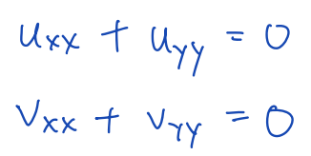

L10
Topic: Vector & covector, tangent space & cotangent space, differential form, complex differentia form, $dz$, $d\overline{z}$, $\frac{∂}{∂z}$, $\frac{∂}{∂\overline{z}}$

Vector:
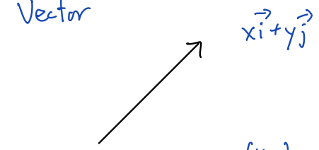
Position vector:
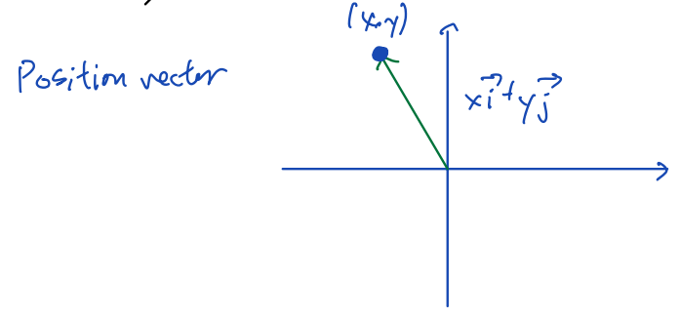

Vector space
Def.: A collection of objects with addition and scalar multiplication, satisfying some axioms

$\left(\vec{p},\vec{v}\right)$
Def.: a vector $\vec{v}$ that emanates from $\vec{p}$
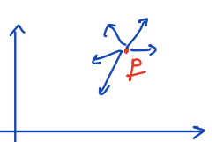
Notation: Write $\left(\vec{p},\vec{v}\right)$ as ${\vec{v}}_{\vec{p}}$

Tangent space
Def.: For ∀vector p,
Tangent space $T_{\vec{p}}≜\{\left(\vec{p},\vec{v}\right) : \vec{v}∈R^{2}\}$
and
$\left(\vec{p},\vec{v_{1}}\right)+\left(\vec{p},{\vec{v}}_{2}\right)≜\left(\vec{p},{\vec{v_{1}}+\vec{v}}_{2}\right)$
$a·\left(\vec{p},\vec{v}\right)≜\left(\vec{p},a\vec{v}\right)$

If $\vec{p}≠\vec{q}$ ⇒ then $T_{\vec{p}}≠T_{\vec{q}}$

E.g.: ……

Vector field
Def.: a function that selects a vector ${\vec{v}}_{\vec{p}}$ for every $\vec{p}$
E.g.: 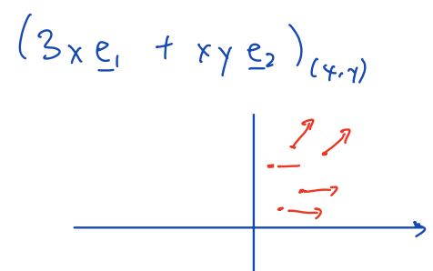

Linear functional/covector
Def.: Let $T_{\vec{p}}^{*}$ be the dual space of $T_{\vec{p}}$,
then every element of $T_{\vec{p}}^{*}$ is linear functional/covector
(functional: a function whose input is a vector and output is a scalar)
E.g.: 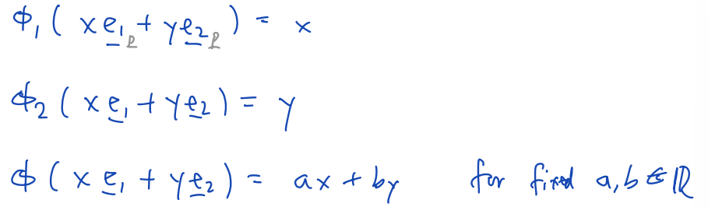

Directional derivative
Def.: $f(x,y)$is a differentiable function
在${\left(re_{1}+se_{2}\right)}_{\vec{p}}$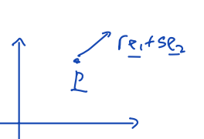上求directional derivative :
$\lim_{h→0}{\frac{f\left(x+r·h,y+s·h\right)}{h}=f_{x}·r+f_{y}·s={\left(∇f\right)}_{\vec{p}}·{\left(re_{1}+se_{2}\right)}_{\vec{p}}}$
Then we can define: $Φ_{f}({\vec{v}}_{\vec{p}})≜{\left(∇f\right)}_{\vec{p}}·({\vec{v}}_{\vec{p}})$
E.g.: 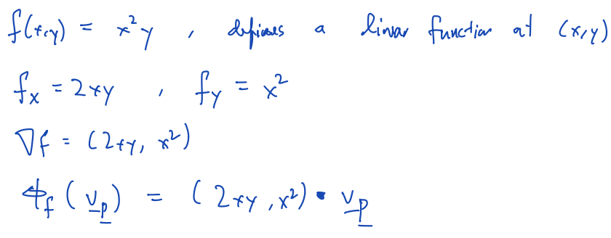

Differential form (?)
Def.: a function that selects a linear functional at every point.
Ex: 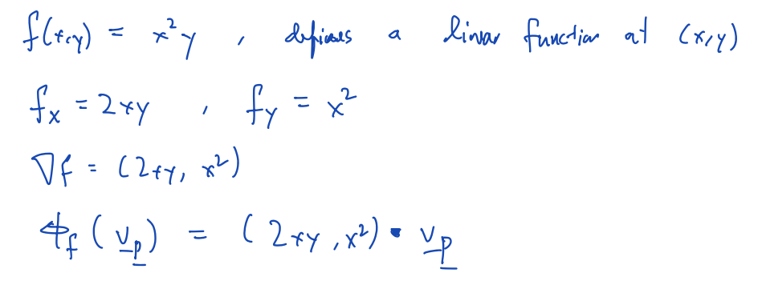

$({df)}_{\vec{p}}$
Def.: a linear functional at $\vec{p}$, defined by ${\left(∇f\right)}_{\vec{p}}·({\vec{v}}_{\vec{p}})$ for $∀(?){\vec{v}}_{\vec{p}}∈T_{\vec{p}}$
(IF $\vec{p}$ is fixed, then the subscript(下标) $\vec{p}$ 就不写了)
E.g.: 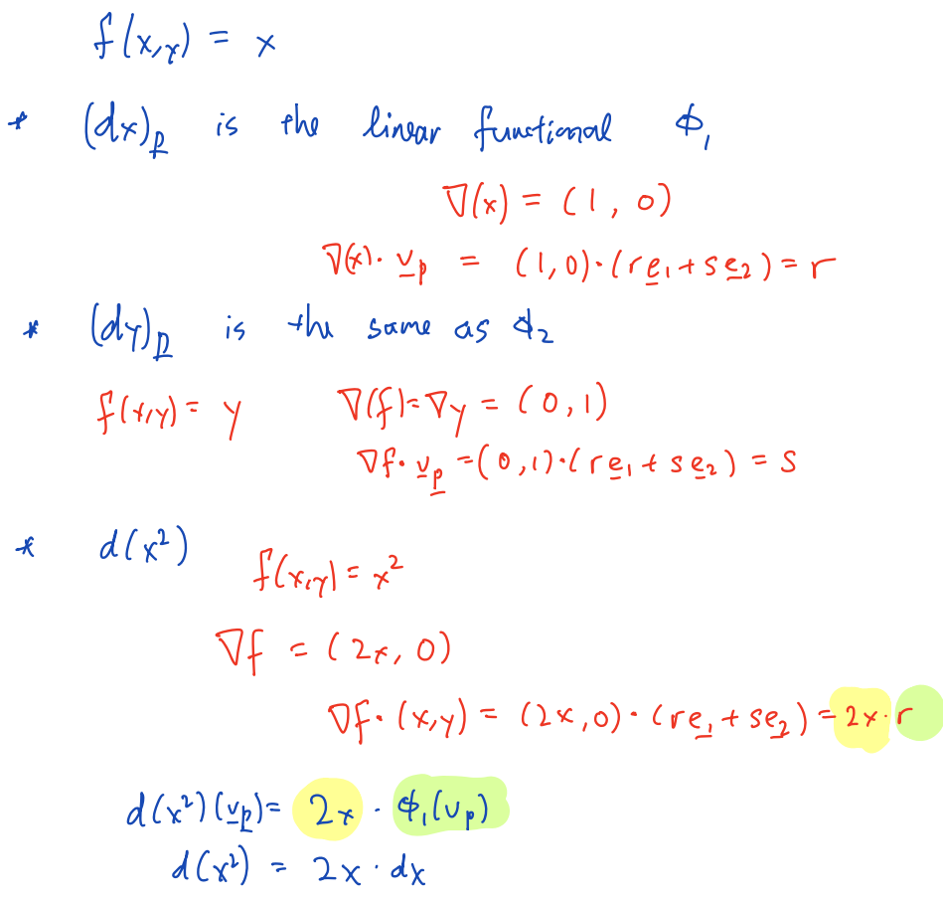

Complex-valued differential form
( ? 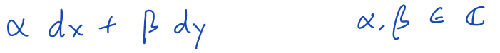 ?)
($E.g.: Let f\left(z\right)=z^{2}, then u\left(x,y\right)=x^{2}-y^{2}, v\left(x,y\right)=2xy$)

$du=u_{x}dx+u_{y}dy$
$dv=v_{x}dx+v_{y}dy$

Def.: $df=du+idv$
${\left(dz\right)}_{\vec{p}}={\left(dx\right)}_{\vec{p}}+i{\left(dy\right)}_{\vec{p}}$
${\left(d\overline{z}\right)}_{\vec{p}}={\left(dx\right)}_{\vec{p}}-i{\left(dy\right)}_{\vec{p}}$
${\left(dx\right)}_{\vec{p}}=\frac{dz+d\overline{z}}{2}$
${\left(dy\right)}_{\vec{p}}=\frac{dz-d\overline{z}}{2}$
$df=$……
$=\left(u_{x}+iv_{x}\right)dx+\left(u_{y}+iv_{y}\right)dy$
$=\frac{∂f}{∂x}\left(\frac{dz+d\overline{z}}{2}\right)+\frac{∂f}{∂y}\left(\frac{dz-d\overline{z}}{2}\right)$
=$\frac{1}{2}\left(\frac{∂}{∂x}f-i\frac{∂}{∂y}f\right)dz+\frac{1}{2}\left(\frac{∂}{∂x}f+i\frac{∂}{∂y}f\right)d\overline{z}$
=$\frac{∂f}{∂z}dz+\frac{∂f}{∂\overline{z}}d\overline{z}$=$df$

$\overline{δ}$-operator
Def.: $\frac{1}{2}(\frac{∂}{∂x}+i\frac{∂}{∂y})$
($\overline{δ}f=\frac{∂f}{∂z}$)

Thm.: $\left\{\begin{aligned}u_{x}=v_{y} \\ u_{y}=-v_{x}\end{aligned}\right.$ ⇔ $\overline{δ}f=0$
Proof: 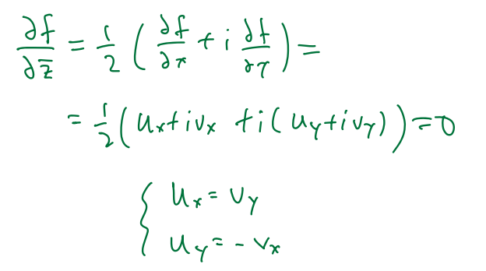

L11
Topic: Multi-valued func.; branch point, branch cut; Riemann surface; log(z), arg(z), $\sqrt{z}$
Let f(x,y) = x+iy
Then $df=f_{x} dx+f_{y}dy=2x\left(\frac{dz+d\overline{z}}{2}\right)+i\left(2y\right)2x\left(\frac{dz+d\overline{z}}{2i}\right)=\left(x+y\right)dz+\left(x-y\right)d\overline{z}$
Also, from $\frac{∂}{∂z}=\frac{1}{2}\left(\frac{∂}{∂x}-i\frac{∂}{∂y}\right)，\frac{∂}{∂\overline{z}}=\frac{1}{2}\left(\frac{∂}{∂x}+i\frac{∂}{∂y}\right)$
$⇒\frac{∂f}{∂z}=\frac{1}{2}\left(f_{x}-if_{y}\right)=\frac{1}{2}\left[2x-i\left(i2y\right)\right]=x+y$
$\frac{∂f}{∂\overline{z}}=\frac{1}{2}\left(f_{x}+if_{y}\right)=\frac{1}{2}\left[2x+i\left(2iy\right)\right]=x-y$

Multi-valued func.
Def.: The output of a multi-valued func. is a set

Branch
Def.: A branch f of a multi-valued func. F is an ordinary func., s.t. f(z)∈F(z)

Path/Curve
Def.: A path/curve is a cont. mapping γ(t) from [a, b] to ℂ

A path is:
Simple ⇔ ∄self-intensection
Closed ⇔ γ(a)=γ(b)

Given multi-function F(z) & a curve γ(t),
for each point on γ(t), select a value from F(γ(t)),
s.t. the values vary continuously
E.g.: ……

E.g. - Q: Travel along a path, assume that we have known the x, y coordinate and the distance traveled. Measure the angle relative to the origin.
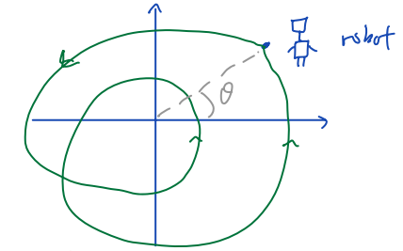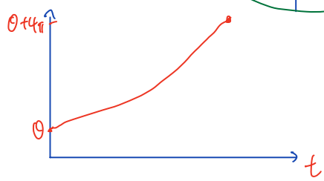
Sol.: Suppose the robot only move in the right half-plane
Then we can use the $\tan^{-1}{\frac{y}{x}}$. Let $A\left(x+iy\right)=\tan^{-1}{\frac{y}{x}}$
If the robot only travel within a half-plane
……

L12
Topic: Winding number, derivative of multi-value func.

Use 2 sheets to cover ℂ ⇒ create a Riemann surface for $\sqrt{z}$

Consider the angle function/argument
Fact: Cannot pick a single cont. branch on ℂ \ {0}
Suppose f(z) is a branch of the angle func.
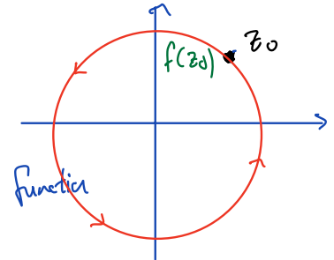
1. Pick a branch cut that prevent going around 0
2. Construct a Riemann surface

(L11: → able to define a cont. angle func. in any half plane)
Ex.: ……

Change of angle in a path
Change of argument = f(z_2) – f(z_1)
f_1(z): the angle func. for the first half plane
f_2(z): the angle func. for the second half plane (the second half plane: contains z_1 → z_2)
Change in angle = $\left[f_{1}\left(z_{1}\right)-f_{1}\left(z_{2}\right)\right]+[f_{2}\left(z_{2}\right)-f_{2}\left(z_{1}\right)]$
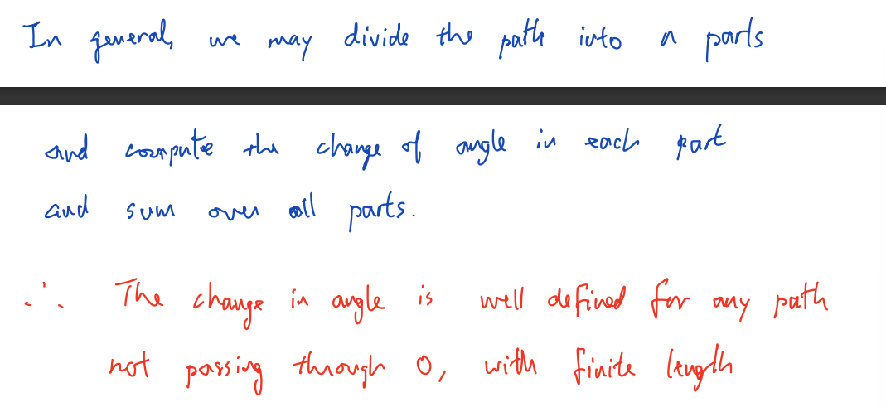

Winding number
Def.: the winding number of a closed path = total change in angle / 2π
Winding number is an integer

Ex. (3个 ……)

Inverse mapping theorem (from real analysis) (__ .?) – (((for: )) derivative of inverse function)
Suppose $\vec{g}'(x_{0},y_{0})$ is invertible
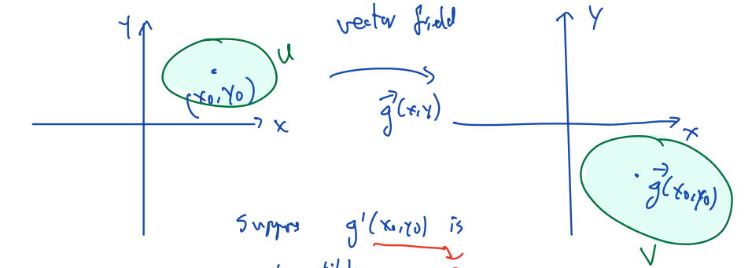
$\left\{\begin{aligned}∃open sets U, V, s.t. func. \vec{g}:U→V is bij. \\ inverse of \vec{g} is diff. \\ \vec{g} is holo.\end{aligned}\right.$ ⇒ ${\vec{g}}^{'}\left(z_{0}\right) is represented by \left[\begin{matrix}a & -b \\ b & a\end{matrix}\right]$
(${\left[\begin{matrix}a & -b \\ b & a\end{matrix}\right]}^{-1} =\frac{1}{a^{2}+b^{2}}\left[\begin{matrix}a & b \\ -b & a\end{matrix}\right]=\left[\begin{matrix}c & -d \\ d & c\end{matrix}\right]$)

Ex. (1个 ……)

L13
Topic: Contour Integral

Line integral

Partition: $a=t_{0}<t_{1}<…<t_{n-1}<t_{n}=b$
Sum: 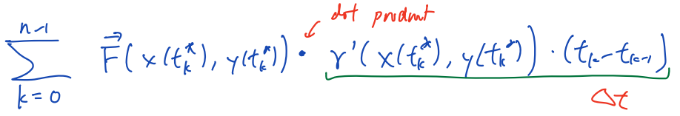
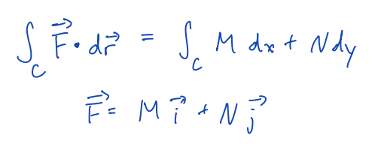

Complex integral on real line
$f:\left[a,b\right]→C$
$f\left(t\right)=u\left(t\right)+i·v\left(t\right)$
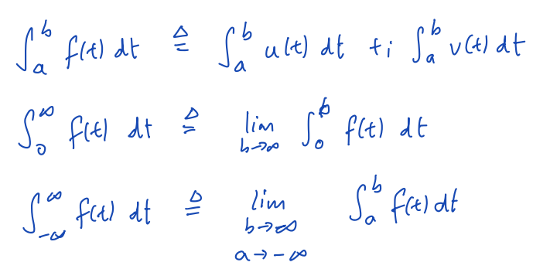

Ex. : 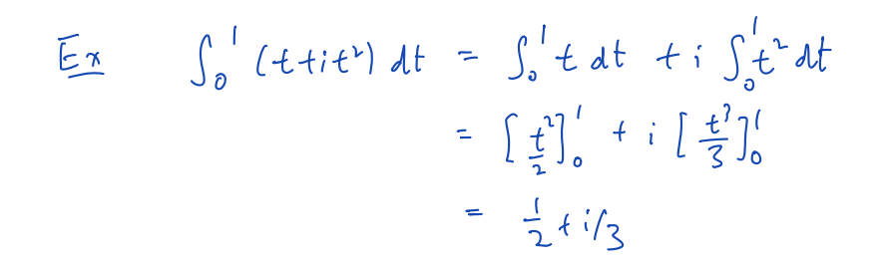

Fouritr transform: $\int_{-∞}^{∞}{f\left(t\right)·e^{-i·ω·t} dt}$
((?)one-side) Laplace transform: $\int_{0}^{∞}{f\left(t\right)·e^{-s·t} dt}, s∈C$

Complex contour(path) parametric representation
$z\left(t\right)=x\left(t\right)+i·y\left(t\right), t∈\left[a,b\right]$

Suppose that $z\left(t\right) is smooth ⇐ \left\{\begin{aligned}x\left(t\right),y\left(t\right) are C^{1} func. \\ ∀t∈\left(a,b\right), \left(x^{'}\left(t\right),y^{'}\left(t\right)\right)≠0\end{aligned}\right.$
$z\left(t\right) is piece-wise smooth ⇐z\left(t\right) is a concatenation\left(串联\right) of smooth curves$
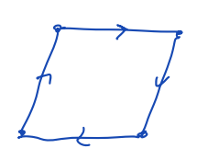

Ex. : 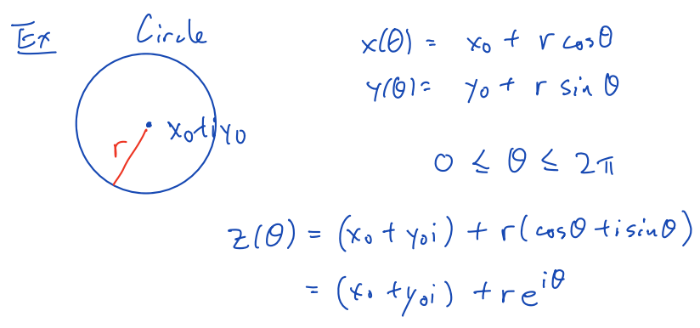

Contour integral
Def.: $\int_{C}{f\left(z\right) dz}=\int_{a}^{b}{f\left(z\left(t\right)\right)·z^{'}\left(t\right) dt} (the "·": complex multiplication)$
$F\left(z\right)=u\left(x,y\right)+i·v(x,y)$
The path C is represented by $z\left(t\right)=x\left(t\right)+i·y\left(t\right), t∈\left[a,b\right]$

Partition:
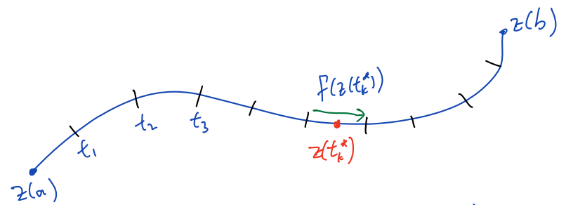
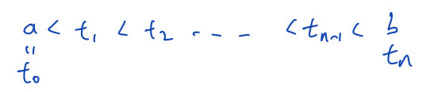
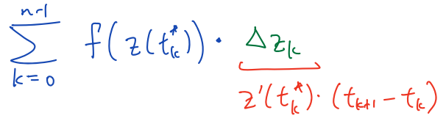

Ex.: 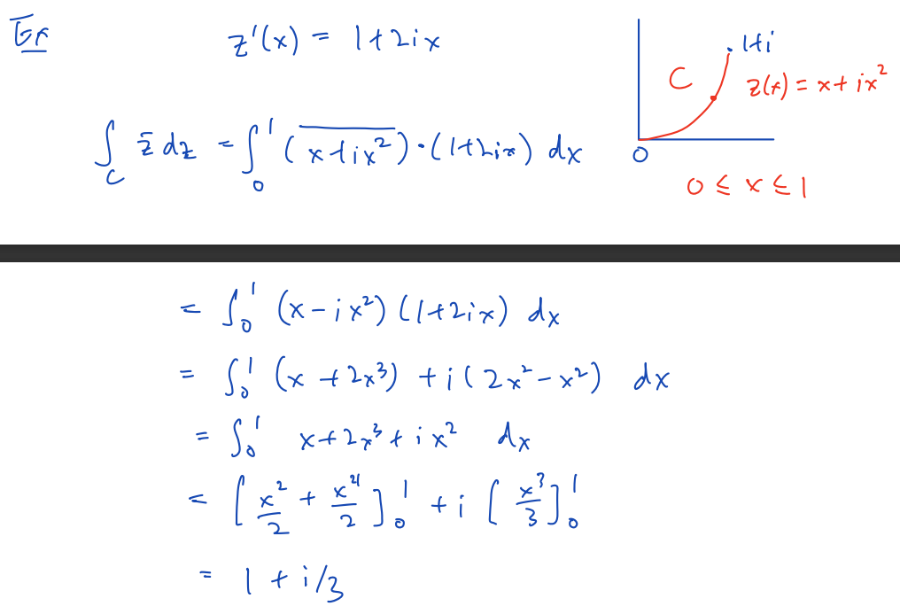

Physical interpretation
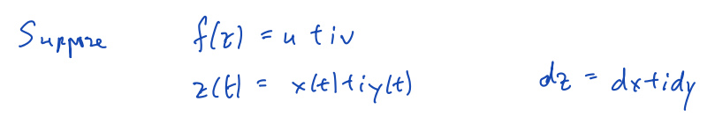
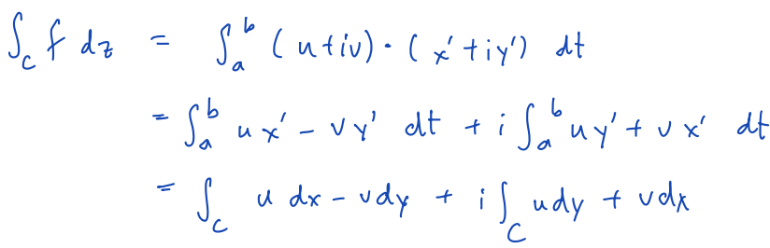

Polya(?) vector field
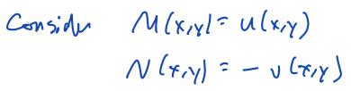
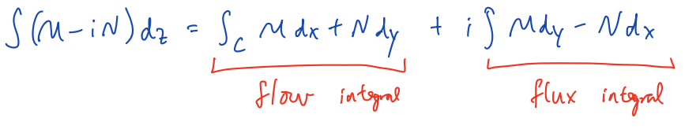
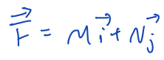

L14
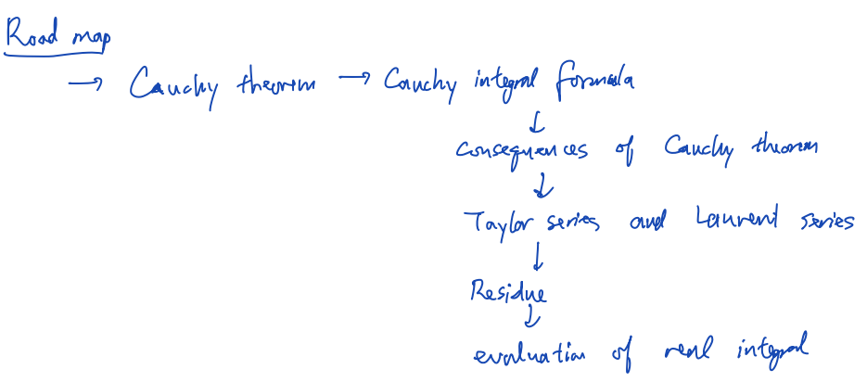
Topic: Independence of parameterization (always), path independence (depends on f(z) on D), primitive function / anti-derivative

Theorem: $\int_{C}{f\left(z\right) dz} is independent of parameterization$
Proof:
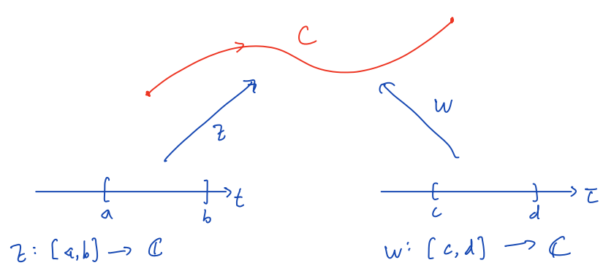
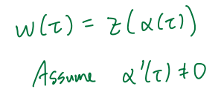
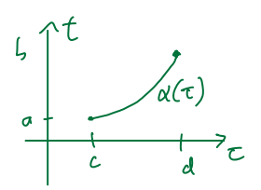
(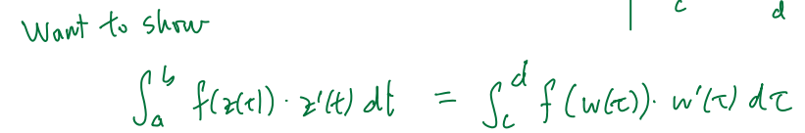)
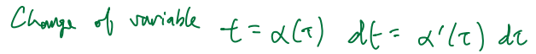
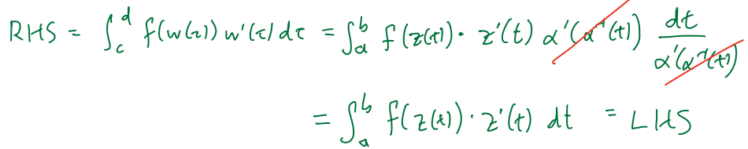

Notation: When C is a closed curve, write $\oint_{C}{f\left(z\right) dz}$

Negative/reverse of a curve
Def.: a curve that consists of the same set of points, but with opposite direction
Notation: -C

Theorem: $\int_{-C}{f\left(z\right) dz} = -\int_{C}{f\left(z\right) dz}$

Notation: $\int_{C_{1}+C_{2}}{f\left(z\right) dz}=\int_{C_{1}}{f\left(z\right) dz}+\int_{C_{2}}{f\left(z\right) dz}$
E.g.: 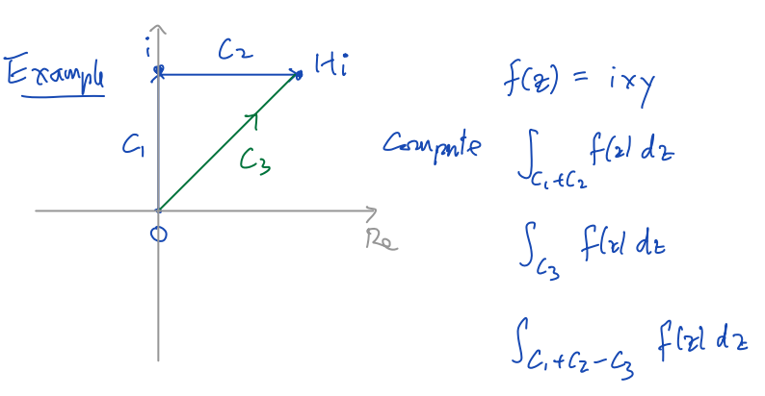
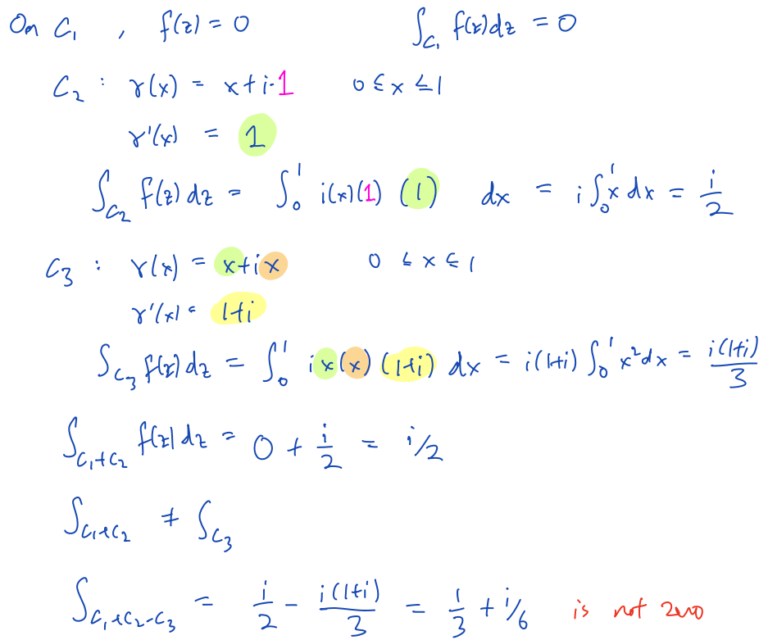

Primitive function / anti-derivative
Def.: $func. F\left(z\right) is primitive function / anti-derivative of func. f\left(z\right)(def. on D)$
$⇐{∀z∈D, F}^{'}\left(z\right)=f(z)$

Theorem: $f\left(z\right) has primitive function in D$
$⇒ ∀curve C∈D, \int_{C}{f\left(z\right) dz}=F\left(z_{2}\right)-F\left(z_{1}\right) (z_{1}:C^{'}s start pt.;z_{2}:end pt. …)$
(piece-wise smooth path也能用此定理)
Proof:
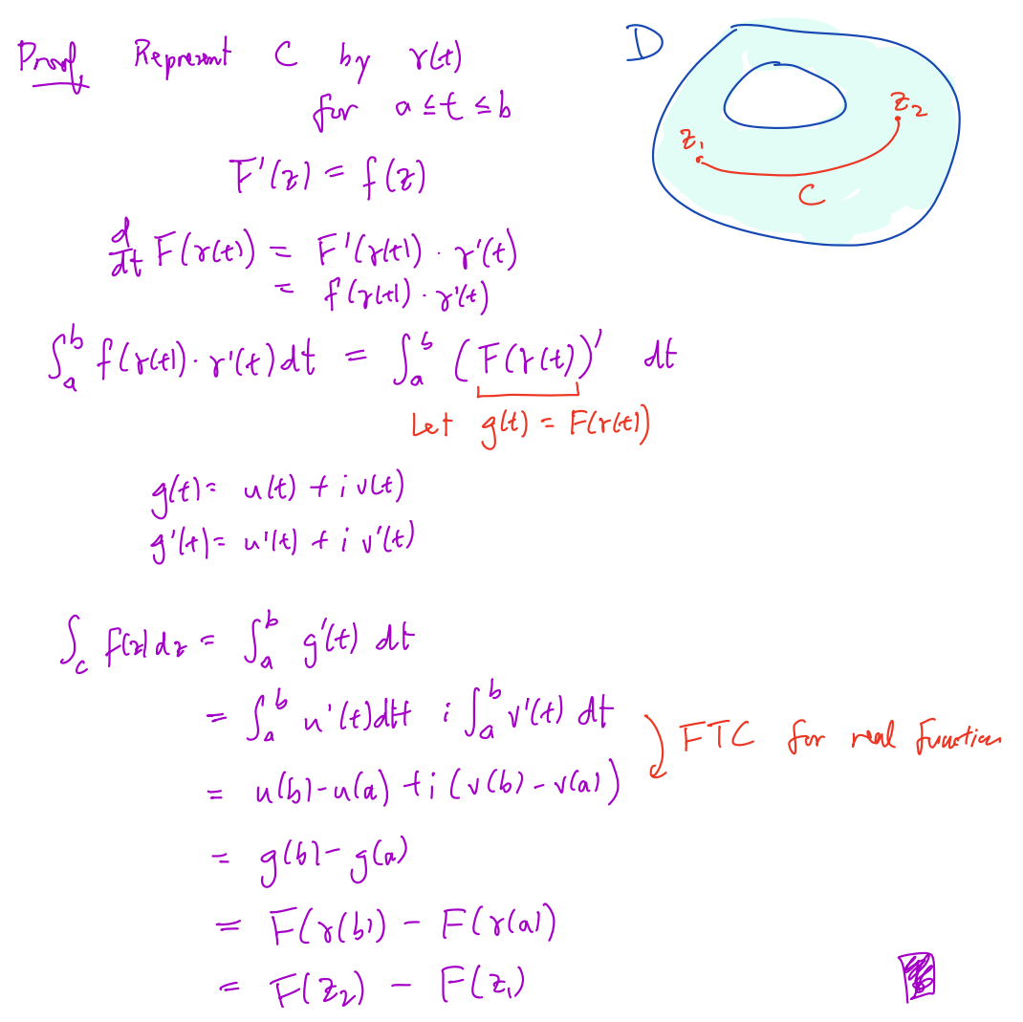
(E.g.×2)
……

L15
Topic: ML inequality, Cauchy-Gorsat theorem for triangle, $\frac{1}{\sqrt{2π}}\int{e^{-\frac{x^{2}}{2}}·e^{-i·t·x} dx=e^{-\frac{t^{2}}{2}}}$

Theorem:
$∀holo. func. f:D→C, \int_{C}{f\left(z\right) dz} is independent of path (always: ∀path C)$
$⇔ ∀closed path C⊂D, \int_{C}{f\left(z\right) dz=0}$
（在复积分的上下文中，术语“独立于路径”是指只要起点和终点相同，函数沿指定域中任何路径的积分值不依赖于所采用的特定路径的性质。）

Proof:
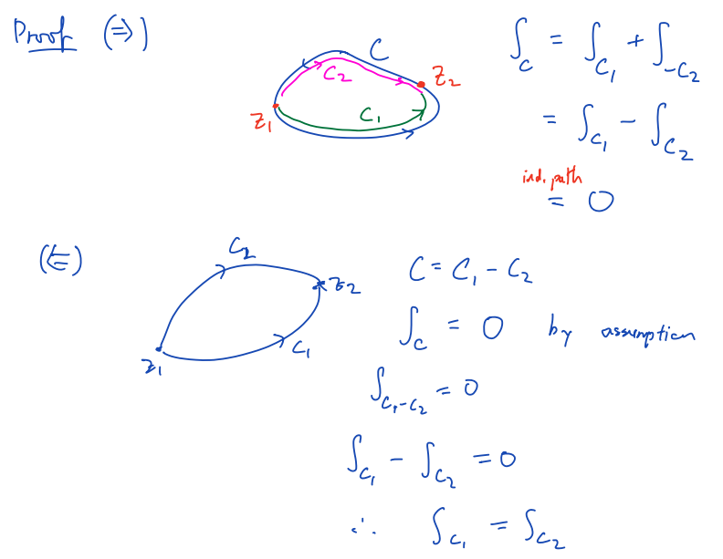

Evaluate $\frac{1}{\sqrt{2π}}\int{e^{-\frac{x^{2}}{2}}·e^{-i·t·x} dx=e^{-\frac{t^{2}}{2}}}$
(已知：$\int_{-∞}^{∞}{e^{-x^{2}}}=\sqrt{π}$)
(以下是不严谨证明，严谨证明见L16)
√ $\sqrt{2π}=\int_{-∞}^{∞}{e^{- \frac{x^{2}}{2}} dx=\int_{-∞}^{∞}{e^{- \frac{{\left(x+3\right)}^{2}}{2}} dx}}$ (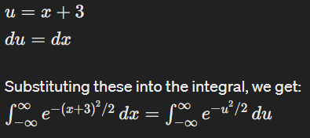)
$=\int_{-∞}^{∞}{e^{- \frac{{\left(x+it\right)}^{2}}{2}} dx}=\int_{-∞}^{∞}{e^{- \frac{\left(x^{2}+2·i·x·t-t^{2}\right)}{2}} dx}$
$\sqrt{2π}·e^{- \frac{t^{2}}{2}}=\int_{-∞}^{∞}{e^{- \frac{x^{2}}{2}}·e^{-i·x·t} dx}$
$e^{- \frac{t^{2}}{2}}=\frac{1}{\sqrt{2π}}·\int_{-∞}^{∞}{e^{- \frac{x^{2}}{2}}·e^{-i·x·t} dx}$

Cauchy Theorem (1):
$\left\{\begin{aligned}f\left(z\right) is holo. in domain D \\ f^{'}\left(z\right) is cont. \\ C is a simple closed curve in domain D\end{aligned} ⇒ \right.\int_{C}{f\left(z\right) dz}=0$
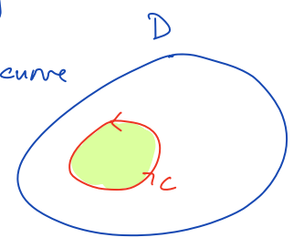

Proof:
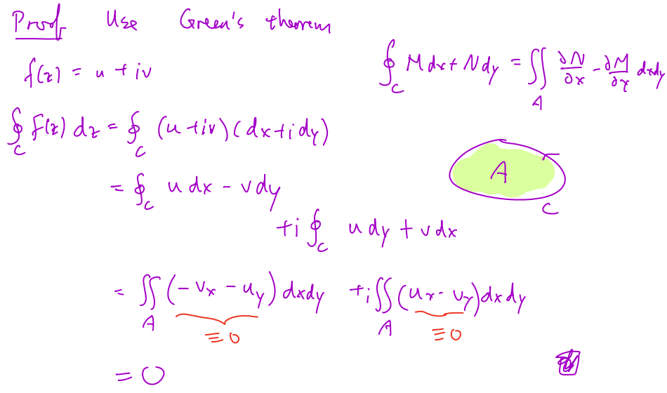

Triangle inequality
$complex-valued func. f\left(z\right) is cont. on \left[a,b\right] ⇒\left|\int_{a}^{b}{f\left(t\right) dt}\right|≤\int_{a}^{b}{\left|f\left(t\right)\right| dt}$

Proof:
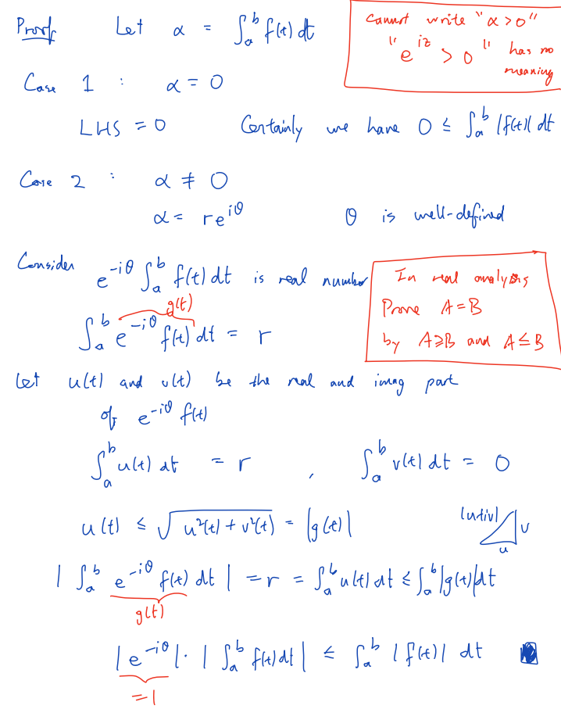

ML inequality
$\left\{\begin{aligned}∀z∈curve C, \left|f\left(z\right)\right|≤M \\ L is the length of curve C\end{aligned}\right. ⇒\left|\int_{C}{f\left(z\right) dz}\right|≤M·L$

Proof:
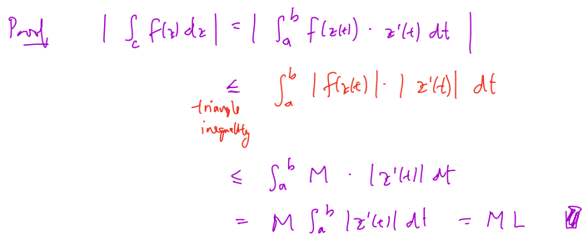

Length of a curve
Def.: L is the length of Curve C ⇔ $L=\int_{a}^{b}{\sqrt{x^{'}{\left(t\right)}^{2}+y^{'}{\left(t\right)}^{2}} dt=\int_{a}^{b}{\left|z^{'}\left(t\right)\right| dt}}$

Cantor intersection theorem
$\left[{\left\{K_{j}\right\}}_{j=1}^{∞} is a seq. of sets, s.t. ∀j∈N, \left\{\begin{aligned}K_{j}≠Φ \\ K_{j} is compact \\ K_{j+1}⊆K_{j}\end{aligned}\right. \right]⇒ (\bigcap_{j=1}^{∞}{K_{j}})≠Φ$

Cauchy-Goursat theorem for a triangle
domain D ∈ ℂ,
func. f: D→ℂ,
T is a triangle whose vertices and interior lie entirely within D (T ⊂ D),
[∂T: the boundary of (triangle) T]
$func. f\left(z\right) is holo. in D ⇒ \int_{∂T}{f\left(z\right) dz}=0$

(Corollary: ... also holds for rectangle: 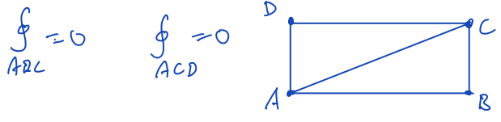)

Proof (of Cauchy-Goursat theorem for a triangle):
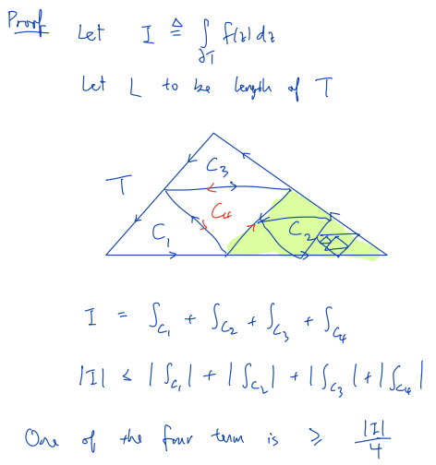
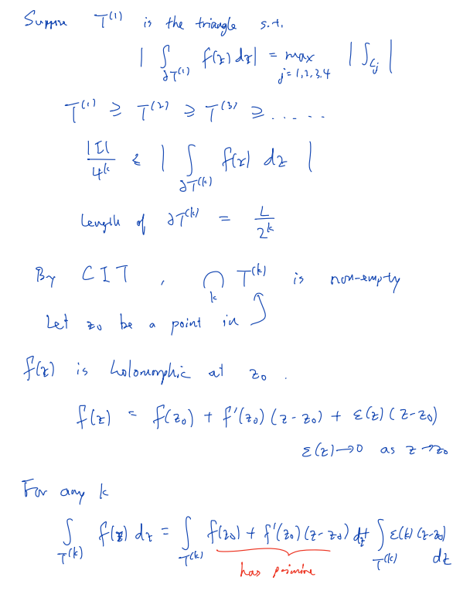
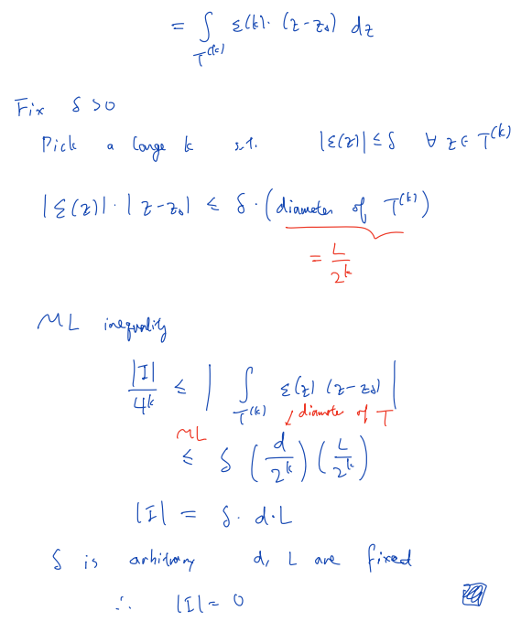

L16
Topic: Application to Gaussian pdf, local primitive, existence of primitive in convex set

Prove $\frac{1}{\sqrt{2π}}\int{e^{-\frac{x^{2}}{2}}·e^{-i·t·x} dx=e^{-\frac{t^{2}}{2}}}$ (rigorous):
( (??) (concerning) the Fourier transform of a Gaussian function)
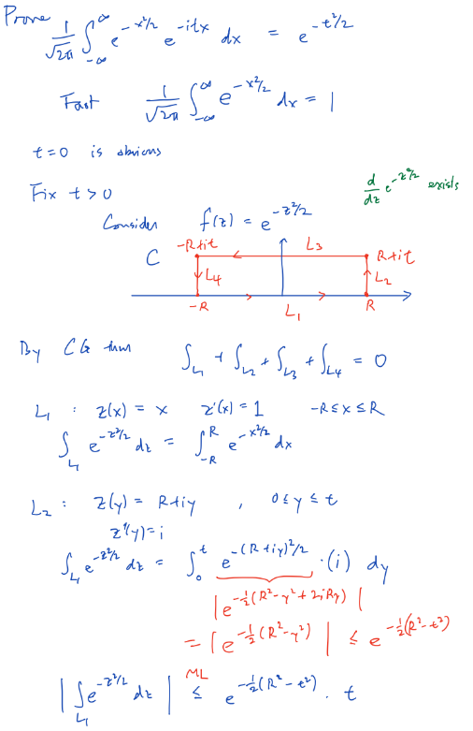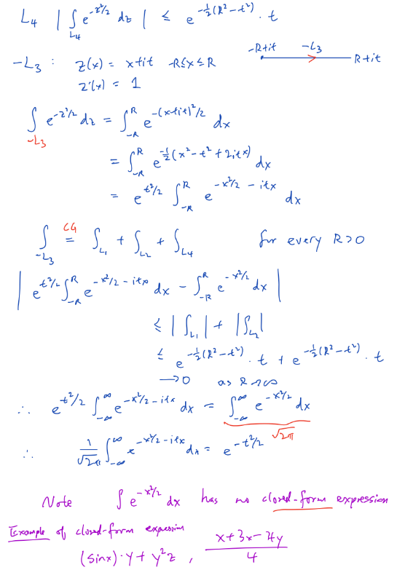
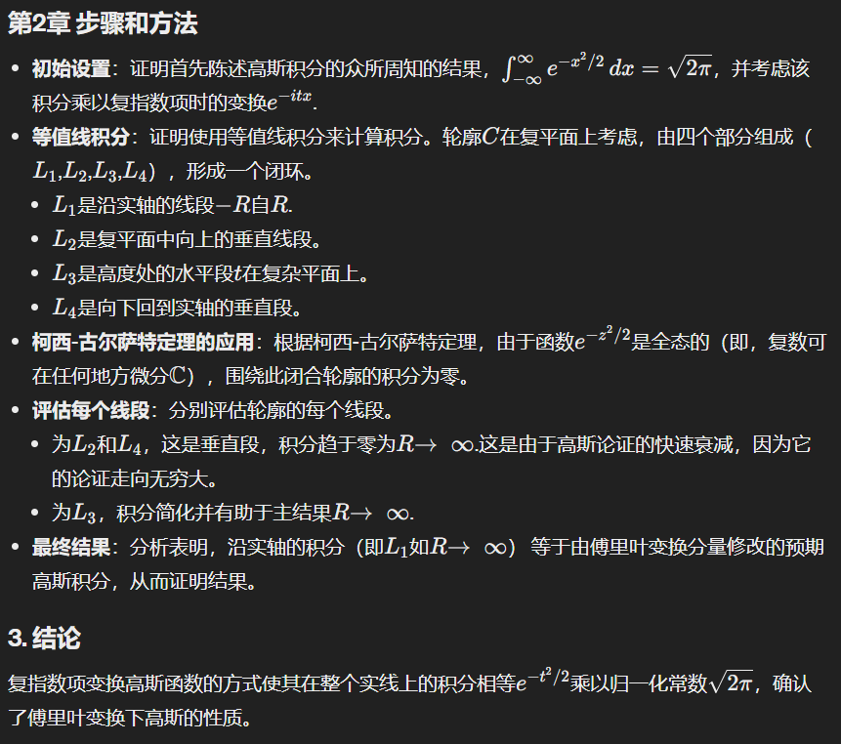

Note:
Closed-form expression: 指可以在有限数量的标准运算中求值的数学表达式。这些运算通常包括加法、减法、乘法、除法，以及本身具有标准闭式表达式（如指数、对数、三角函数及其任何组合）的函数。
$\int{e^{-\frac{x^{2}}{2}} dx}$ has no closed-form exp.
(Non-closed form
E.g.: )

Local Primitive
f(z) has local primitive in a domain D
$⇔ \left(def.\right) ∃F\left(z\right):D→C,$
$s.t. ∀z∈D, F’(z)=f(z)$
$⇒ \oint_{C}{f\left(z\right) dz=0}$ 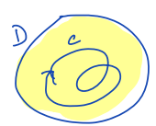
Construction:
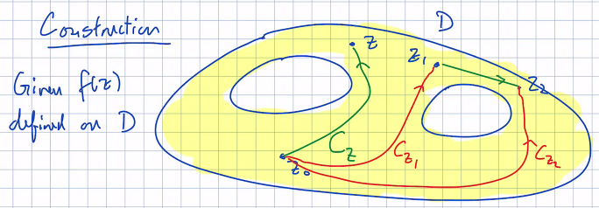
$∀z∈D, pick a contour C_{z};let F\left(z\right)=\int_{C_{z}}{f\left(z\right) dz}$
Requirement(?): z_1 and z_2 are connected by line segment in D
$F\left(z_{1}\right)=F\left(z_{2}\right)+\int_{z_{1}→z_{2}}{f\left(z\right) dz (\left(此积分为\right) \left(?\right) line sement)}$

Thm.:
Open and connected set D ⊂ ℂ
f: D→ℂ

$\left\{\begin{aligned}f\left(z\right) is cont. in D \\ \left(\left\{\begin{aligned}z_{1} and z_{2} are connected by line segment in D \\ F\left(z_{1}\right)=F\left(z_{2}\right)+\int_{z_{1}→z_{2}}{f\left(z\right) dz \left(\left(此积分为\right) \left(?\right) line sement\right)}\end{aligned}\right.\right)\end{aligned}\right.$
$⇒F\left(z\right)=\int_{C_{z}}{f\left(z\right) dz is a local primitive of f\left(z\right) in D}$

Proof:
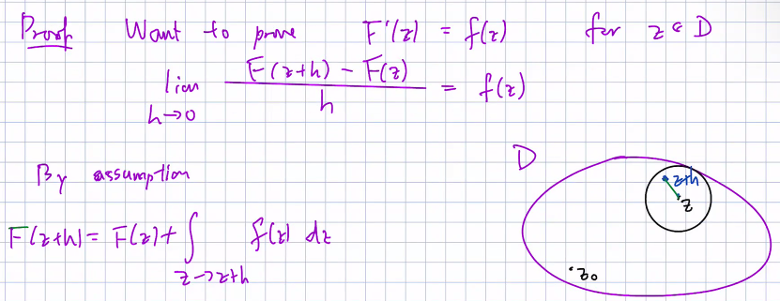
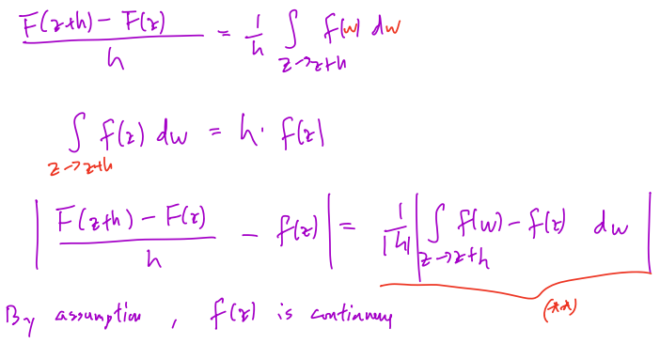
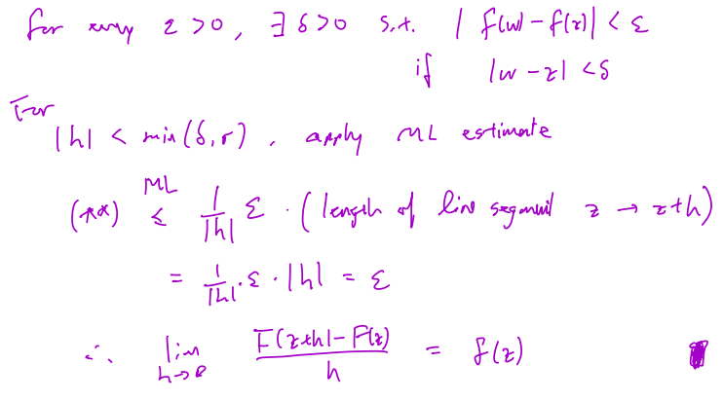

Thm.:
domain D ⊂ C is a simply connected,
𝑓: 𝐷→𝐶 is cont.
$∀path C connecting z1, z2 (in D) , \int_{C}{f\left(z\right) dz} is indep. of C$
$⇔ ∃func. F:D→C,$
$s.t. ∀z∈C, F'\left(z\right)=f(z) (F\left(z\right) \left(?\right) is a local primitive of f\left(z\right) in D)$

Proof:
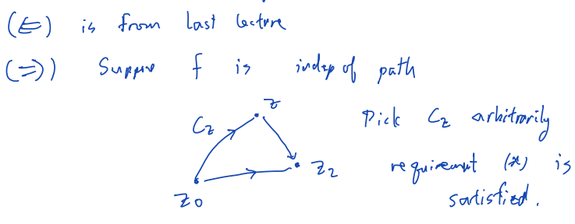

Thm:
$\left\{\begin{aligned}set D ⊂ C is convex and open \\ f:D→C is holo. (∀holo. func. f:D→C)\end{aligned}\right.$
$⇒ ∃func. F:D→C,$
$s.t. ∀z∈C, F'\left(z\right)=f(z) (F\left(z\right) \left(?\right) is a local primitive of f\left(z\right) in D)$

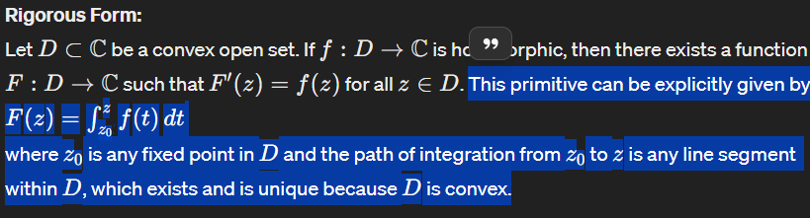

Proof:
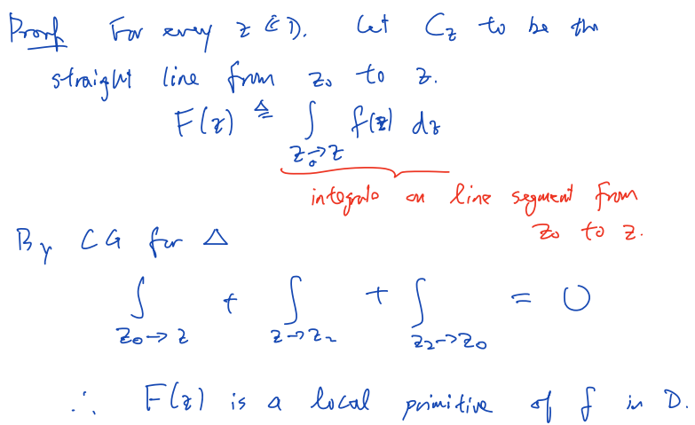
E.g.: 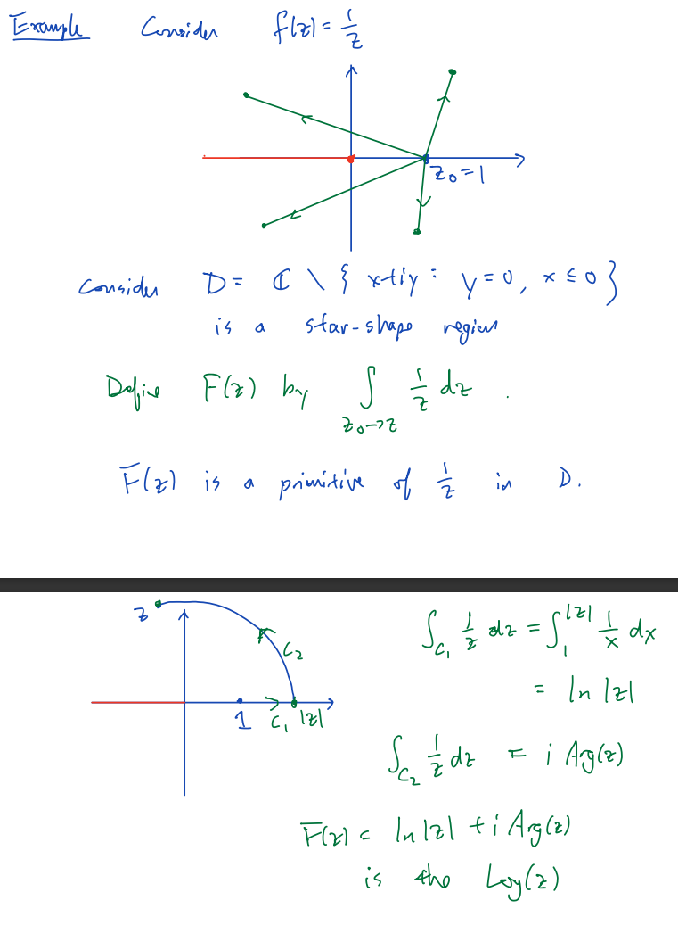

A more general form of Cauchy theorem
Simply Connected Domain
$\left\{\begin{aligned}domain D is simply connected \\ func. f: D→C is holo. in D \\ curve C⊂D is closed\end{aligned}\right. ⇒ \oint_{C}{f\left(z\right) dz}=0$

Simple Closed Curve
$\left\{\begin{aligned}curve C is simple closed \\ func. f: C→C is holo.\end{aligned}\right. ⇒ \oint_{C}{f\left(z\right) dz}=0$

Definitions and Additional Information:
Simple Curve
Def.: A curve that does not cross itself and encloses a simply connected area.

Not Simple Curve
Def.: A curve that crosses itself or does not enclose a simply connected area.

Star-Shaped Domain
Def.: A domain D is star-shaped
$⇐ ∃ a base pt. z_{0},$
$s.t. ∀z∈D,$
$the line segment from z_{0} to z lies entirely within D.$
The primitive function F(z) in a domain with a star shape:
Def.: F(z)=∫ z 0zf(t)dt where 𝑧0 is the base point and the path of integration is the line segment from 𝑧0 to 𝑧 within 𝐷.

(This concept is used to ensure that certain types of domains, even if not simply connected, can allow integrals depending on a central point to be evaluated effectively.)

L17
Topic: Cauchy integral formula, Liouville thm., fundamental thm. of algebra, power series expansion

Cauchy integral formula
$\left\{\begin{aligned}domain D is convex \\ contour C⊂D is circuar \\ func. f:D→C is holo. \end{aligned} ⇒ ∀z∈C\right., f\left(z\right)=\frac{1}{2πi}\oint_{C}{\frac{f\left(w\right)}{w-z} dw}$
(f(w) only depends on the curve C)
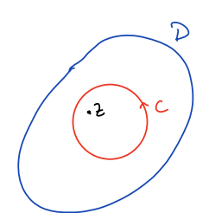

Proof (idea):
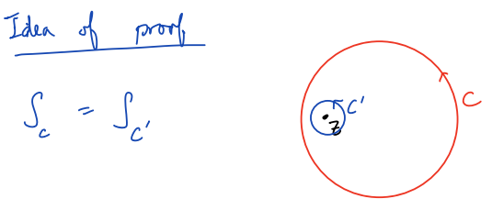
Proof:
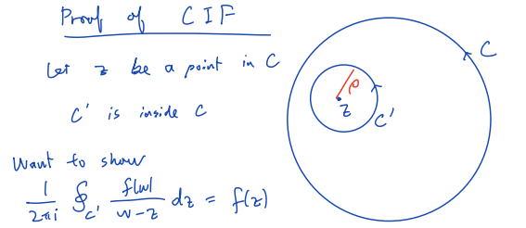
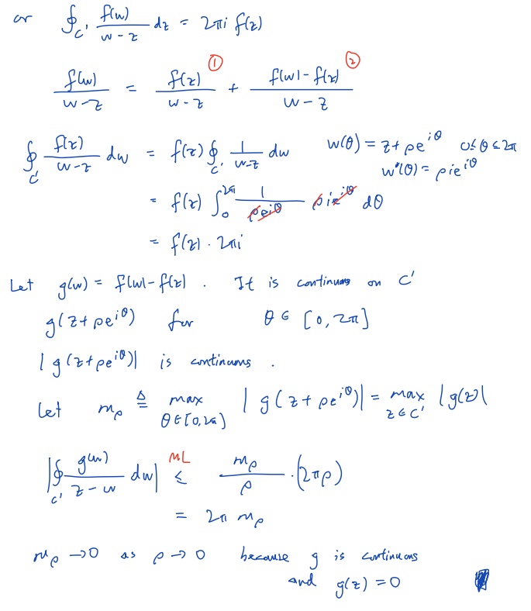

Deformation thm.
$\left\{\begin{aligned}func. g\left(z\right):D→C is holo. in C_{1}\backslash \{center of C_{2}\} \\ contours C_{1}, C_{2}⊂D are closed \\ C_{2} is entirely closed by C_{1}\end{aligned}\right. ⇒ \oint_{C_{1}}{g\left(z\right) dz}=\oint_{C_{2}}{g\left(z\right) dz}$

Proof:
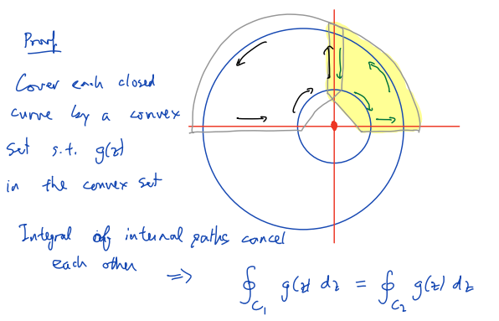

E.g.:
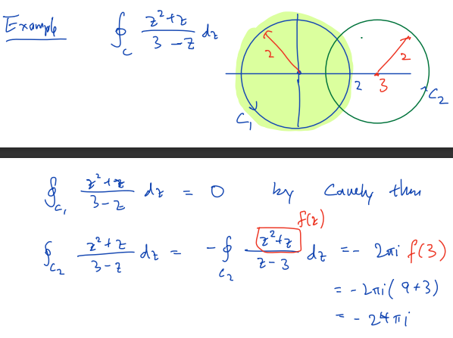

Liouville thm.
$\left\{\begin{aligned}func. f is entire \\ f is bdd. on C (∃M∈R, s.t. ∀z∈C, \left|f\left(z\right)\right|≤M)\end{aligned}\right. ⇒ ∀z∈C, f\left(z\right)=c is a constant)$

Proof:
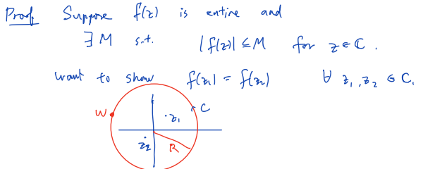
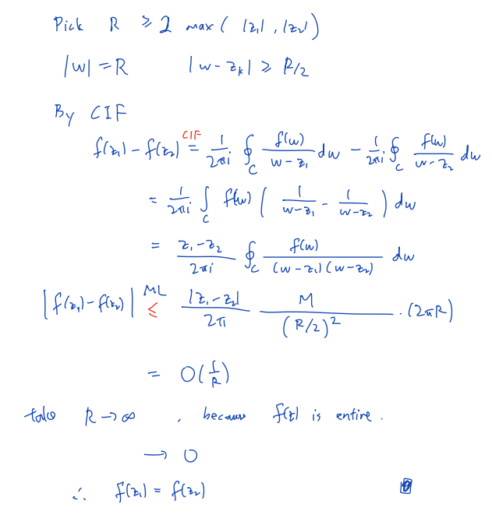

E.g.:
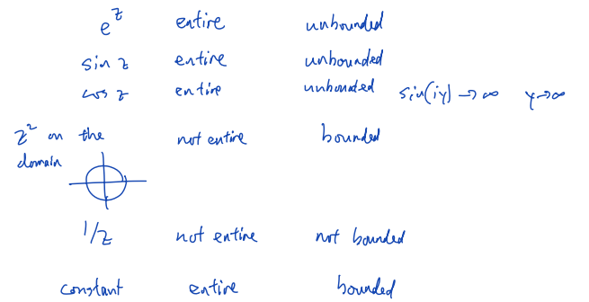

L18 Power series expansion
Topic: Existence of power series for holomorphic function ( ?) uniqueness

$f\left(z\right)=\sum_{k=0}^{∞}{a_{k}z^{k}}$
$f\left(z\right) converges at z_{0}=a+ib ⇒ f\left(z\right) converges for ∀z where \left|z\right|<\sqrt{a^{2}+b^{2}}$
$f\left(z\right) diverges at z_{0}=a+ib ⇒ f\left(z\right) diverges for ∀z where \left|z\right|>\sqrt{a^{2}+b^{2}}$

The region of convergence of d(z) has circular shape
The radius of convergence R is the radius of region l convergence (??)

Hadamard formula: $R=\frac{1}{\lim_{k→∞}{\sup{{\left|a_{k}\right|}^{\frac{1}{k}}}}}$

Thm.: $f\left(z\right)=\sum_{k=0}^{∞}{a_{k}·{\left(z-z_{0}\right)}^{k}} has radius of conv. >0$
$⇒f^{'}\left(z\right)=\sum_{k=1}^{∞}{{k·a}_{k}·z^{k-1}}$

Corollary: $f\left(z\right)=\sum_{k=0}^{∞}{a_{k}·{\left(z-z_{0}\right)}^{k}} is ∞-differentiable$

Analytic
Def.: $A function f\left(z\right) is analytic at z_{0}$
$⇔ ∃r, s.t. f\left(z\right)=\sum_{k=0}^{∞}{a_{k}·{\left(z-z_{0}\right)}^{k}} for ∀z where \left|z-z_{0}\right|<r$

$A function f\left(z\right) is analytic in domain D$
$⇔ ∀z_{0}∈C, f\left(z\right) is analytic at z_{0}$

Thm.: $\left\{\begin{aligned}f\left(z\right) is a complex function \\ f\left(z\right) is holomorphic at z_{0} \\ ∃r, s.t. f\left(z\right) is differentiable at ∀z where \left|z-z_{0}\right|≤r\end{aligned}\right.$
$⇒ f\left(z\right) is analytic at z_{0}$
$⇔f\left(z\right)=\sum_{k=0}^{∞}{a_{k}·{\left(z-z_{0}\right)}^{k}} for ∀z where \left|z-z_{0}\right|<r$
$with a_{k}=\frac{1}{2πi}\oint_{C}{\frac{f\left(w\right)}{{\left(w-z_{0}\right)}^{k+1}} dw}$

Proof (non-rigorous):
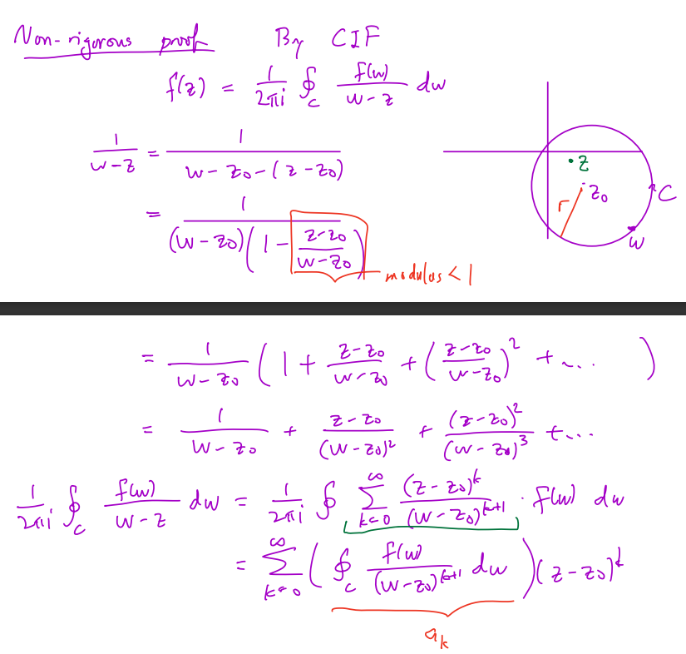

Proof (rigorous):
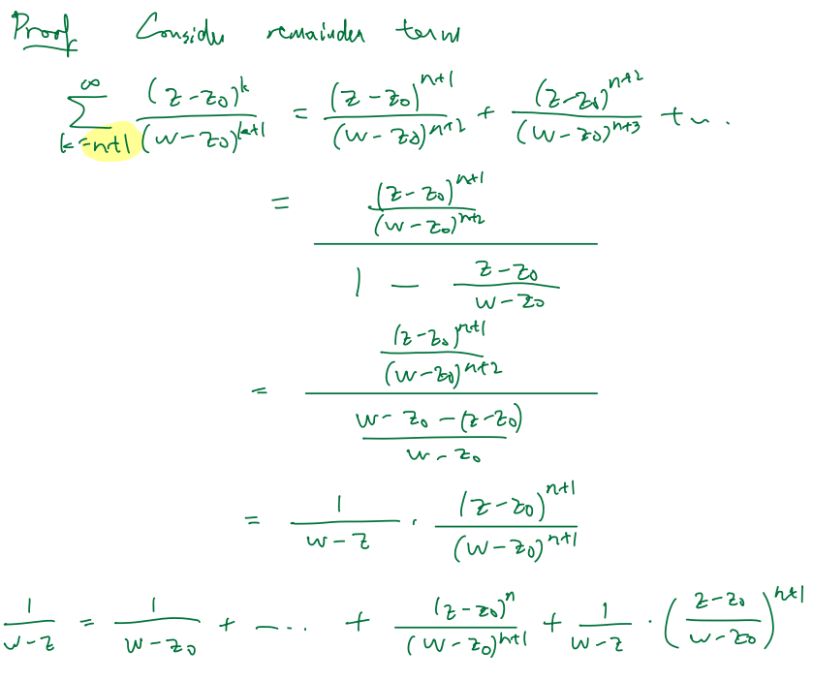
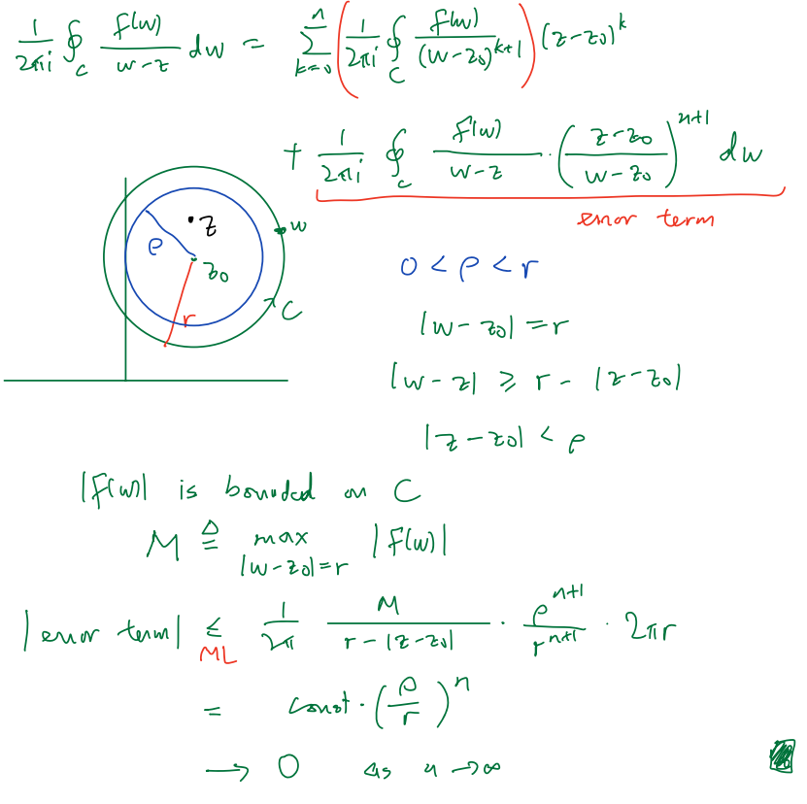

Thm.:
(Usually: $S=\left\{z:0<\left|z-z_{0}\right|<r\right\}$)
$\left\{\begin{aligned}f\left(z\right)=\sum_{k=0}^{∞}{a_{k}{\left(z-z_{0}\right)}^{k}} \\ g\left(z\right)=\sum_{k=0}^{∞}{b_{k}{\left(z-z_{0}\right)}^{k}} \\ set S⊂C has an accumulation point (∃z_{0}, s.t. \left( ∀ε>0, ∃z∈S, s.t. 0<\left|z-z_{0}\right|<ε\right)) \\ ∀z∈S, f\left(z\right)=g\left(z\right)\end{aligned}\right.$
$⇒ ∀k, a_{k}=b_{k}$

L19 Identity theorem
Topic: Uniqueness of coefficients of power series, CIF for derivative – application to real integral, Identity theorem, maximal modulus principal

Uniqueness of power series

Thm. 1
$\left\{\begin{aligned}h\left(z\right)=\sum_{n=0}^{∞}{c_{n}{\left(z-z_{0}\right)}^{n}} \\ ∀z where \left|z-z_{0}\right|<r, h\left(z\right)=0\end{aligned} ⇒∀n, c_{n}=0\right.$

Thm. 2
$\left\{\begin{aligned}h\left(z\right)=\sum_{n=0}^{∞}{c_{n}{\left(z-z_{0}\right)}^{n}} \\ ∃set S⊂C has an accumulation point \\ ∀z∈S, h\left(z\right)=0\end{aligned}\right. ⇒∀n, c_{n}=0$

……
……

Identity theorem
$\left\{\begin{aligned} f\left(z\right) and g\left(z\right) are def. on domain D \\ ∀z∈D, f\left(z\right)=g\left(z\right)\end{aligned}\right.$
⇒ $f\left(z\right)=g\left(z\right)on a sequence of points that has an accumulation point in D$
Proof:
(⇐)
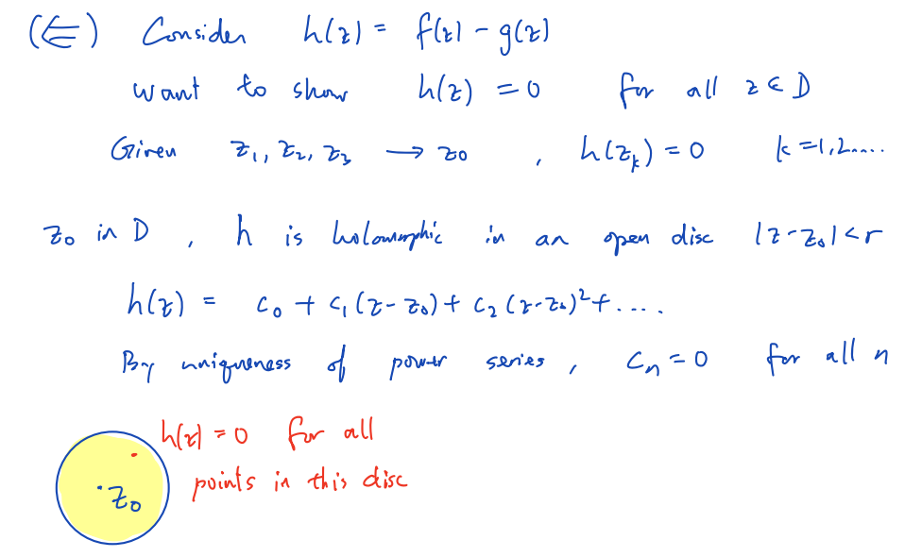
(⇒: obvious)

……

L20
Topic: Maximum modulus principle, zero, zero order, (isolated) singularity

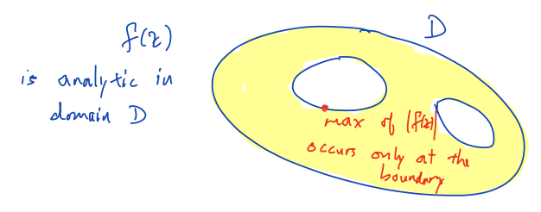

Thm.
$\left\{\begin{aligned}f\left(z\right) is holo. in D \\ \max_{z}\left(\left|f\left(z\right)\right|\right)=f\left(z_{0}\right) and z_{0}∈D\end{aligned}\right. ⇒∃constant c∈C, s.t. ∀z∈C, f\left(z\right)=c$

Proof:
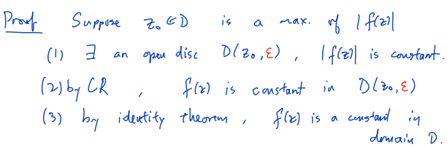

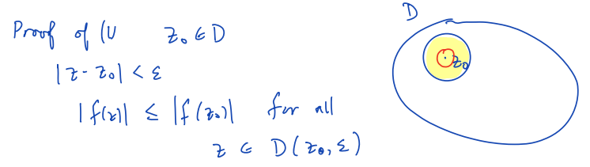
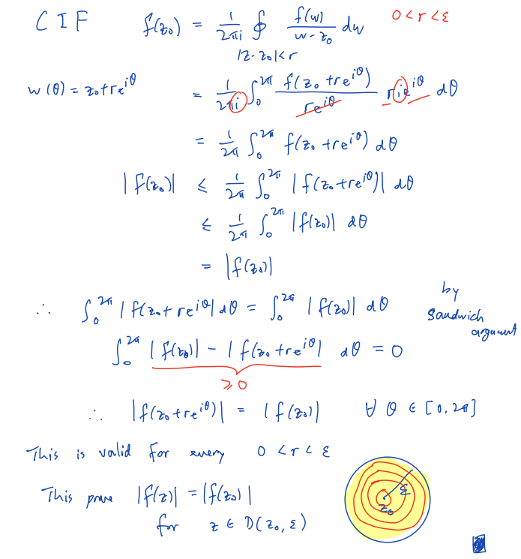

Zero
Def.: $z_{0} is a zero of f\left(z\right) ⇔f\left(z_{0}\right)=0$
Thm.
𝑓 is a holomorphic (non-zero) function on a domain 𝐷⊆𝐶
⇒ the set of zeros of 𝑓 in 𝐷 has no accumulation point in 𝐷

Order
Def.: $a zero z_{0} of f\left(z\right) is of order m$
$⇔f\left(z\right)=$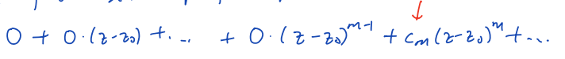
(c_m≠0)

Singular point
Def.: $z_{0} is a singular point of f\left(z\right) ⇔f is not complex diff. at z_{0}$

Isolated
Def.: $a singular point z_{0} of f\left(z\right) is isolated$
$⇔ ∃r, s.t. f is holo. in punctured disc 0<\left|z-z_{0}\right|<r$
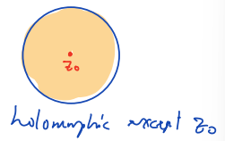
An isolated singular point $z_{0}$ is:
Removable singularity
$⇔ ∃r, s.t. f\left(z\right) is bdd. \left(∃M, s.t. \left|f\left(z\right)\right|<M\right) in D\backslash \{z_{0}\},$
$where D=\{z∈C: \left|z-z_{0}\right|<r\}$
A pole
$⇔ \lim_{z→z_{0}}\left|f\left(z\right)\right|=∞$
Essential singularity
$⇔otherwise$

E.g.:
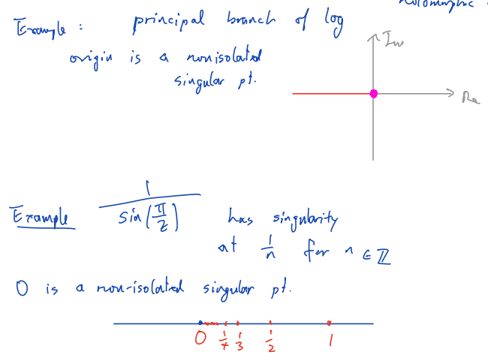
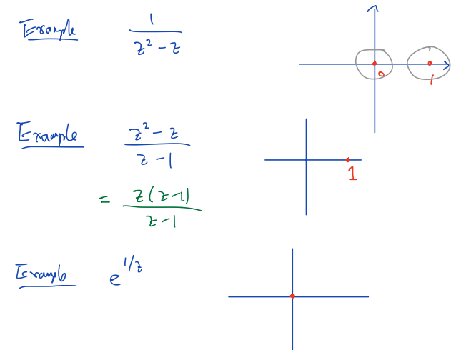

L21
Topic: Cauchy theorem for function with singularity, removable singularity, pole order Lauraut series, residue

Cauchy theorem for functions with isolated singularities
$\left\{\begin{aligned}f is holo. in D except at the finite number of singular points z_{1}, …, z_{n} \\ C_{1}, …, C_{n} are simple closed contours around z_{1}, …, z_{n} \\ ∀i, C_{i} is in C and does not enclose any other singular points\end{aligned}\right.$
$⇒ \oint_{C}{f\left(z\right) dz}=\oint_{C_{1}}{f\left(z\right) dz}+…+\oint_{C_{n}}{f\left(z\right) dz}=\sum_{i=1}^{n}{\oint_{C_{i}}{f\left(z\right) dz}}$
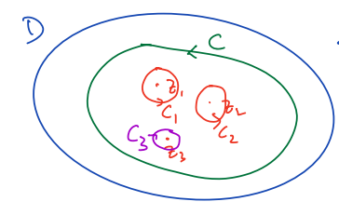

Proof:
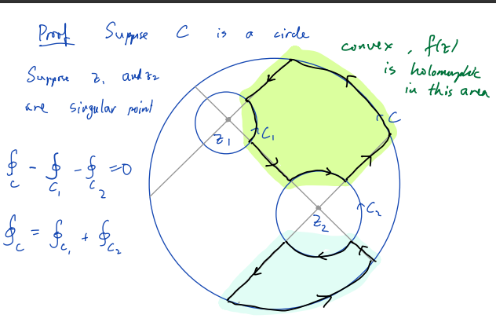

Removable singularity

Thm.
$f\left(z\right) is holo. and bdd. \left(∃M, s.t. \left|f\left(z\right)\right|≤M\right) in D=\left\{z∈C: 0<\left|z-z_{0}\right|<r\right\}$
$⇒ ∃\tilde{f}\left(z\right) on D∪\left\{z∈C: \left|z-z_{0}\right|=0\right\},$
$where \left\{\begin{aligned}∀z∈D, \tilde{f}\left(z\right)=f\left(z\right) \\ \tilde{f}\left(z\right) is diff. in D∪\left\{z∈C: \left|z-z_{0}\right|=0\right\}\end{aligned}\right.$

Proof:
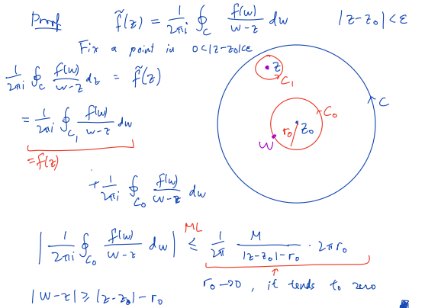

……

(?)
if 𝑧_0 is a pole of a holomorphic function 𝑓(𝑧)
then the reciprocal of 𝑓(𝑧), i.e., 1/𝑓(𝑧)​, has a removable singularity at 𝑧_0

Proof:
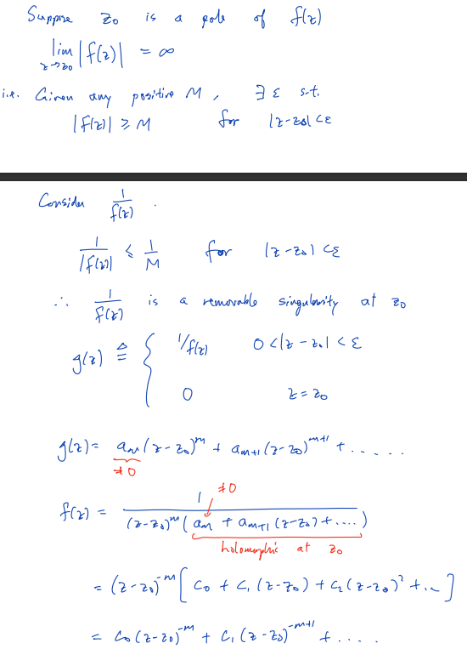ss

Order of pole
Def.: the order of pole at z_0 = the order of zero of 1/f(z) at z_0

Laurent series
Def: $\sum_{n=-∞}^{∞}{c_{n}{\left(z-z_{0}\right)}^{n}}$
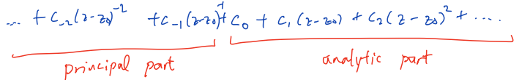
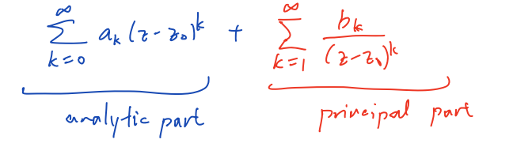

Convergence
A Laurent series $\sum_{n=-∞}^{∞}{c_{n}{\left(z-z_{0}\right)}^{n}}$ is conv.
⇔ $\left\{\begin{aligned} its principal part conv. \\ its analytic part conv.\end{aligned}\right.$

Region of convergence
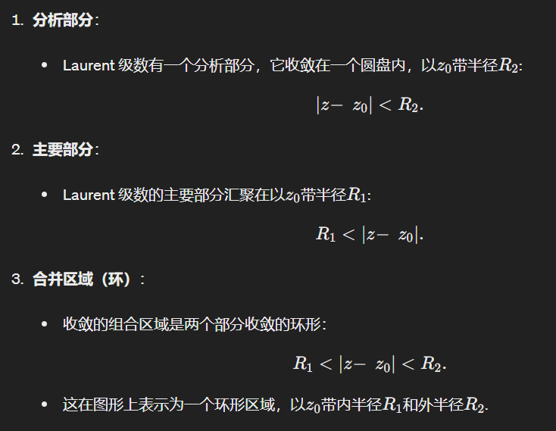

Thm.
$\left\{\begin{aligned}f\left(z\right) is holo. on R_{1}<\left|z-z_{0}\right|<R_{2} \\ ∃series {\left\{a_{k}\right\}}_{k=∞}^{∞}, s.t. f\left(z\right)=\sum_{k=-∞}^{∞}{a_{k}{\left(z-z_{0}\right)}^{k}}\end{aligned}\right.$
$⇒ ∀k, a_{k}=\frac{1}{2πi}\oint_{C}{\frac{f\left(z\right)}{{\left(z-z_{0}\right)}^{k+1}} dz}$

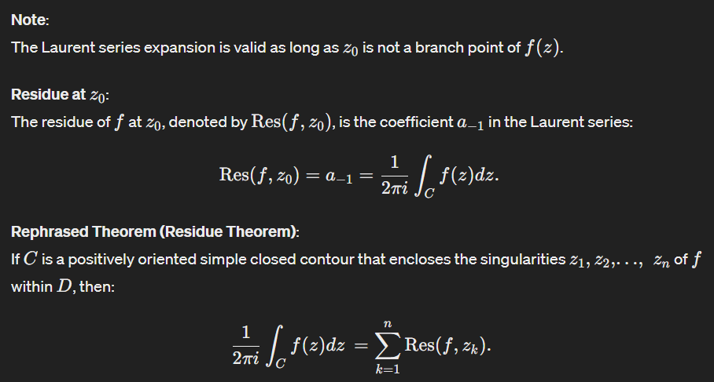

L22
Topic: Residue: define, compute, apply=

Singular point
Removable singularity: principal part=0
Pole: 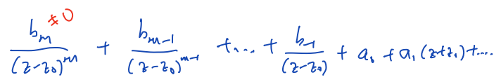
Simple pole: m=1
Double pole: m=2
Triple pole: m=3
Essential singularity: principal part里面有∞多个terms

Residue
Def.:
$f\left(z\right)=\sum_{n=-∞}^{∞}{b_{k}{\left(z-z_{0}\right)}^{k}}$
The residue of f(z) at z_0: $Res\left(f, z_{0}\right)=b_{-1} (见上)$

Uniqueness of power series
$f\left(z\right)=\sum_{n=-∞}^{∞}{b_{k}{\left(z-z_{0}\right)}^{k}} in R_{1}<\left|z-z_{0}\right|<R_{2}$
$⇒∀k, b_{k}=\frac{1}{2πi}\oint_{C}{\frac{f\left(z\right)}{{\left(z-z_{0}\right)}^{k+1}} dz}$
C is a closed curve in the annulus
Winding of C = 1

……

L23
Topic:

Semicircular contour

Deformation theorem

Principal value

Residue theorem

Thm.

Proof:

Residue theorem

Jordan Lemma

L24
Topic:

Singular point / branch point

Branch cut at positive real axis

Integral on a branch cut

L25
Topic: Winding number, argument principle, Rouche theorem

Winding number
Def.:

Lemma

Thm.

Thm. (Argument principle)

Corollary

Rouche theorem

L26
Topic: Morera theorem, locally uniform convergence, analytic continuation, application to Riemann zeta function

Identity theorem

Cauchy theorem

Morera theorem

Thm.

Thm.

Thm.

Analytic continuation by power series

Riemann hypothesis

L27
Topic:

E.g.: Compute ...

Sol. 1:
Sol. 2:
Sol. 3:

Fundamental theorem of algebra

Sol. 1:
Sol. 2:

